**ELECTRONIC:**

When a user opens the browser

enters the URL(https://www.shoppersstack.com/), the Welcome page should be displayed.

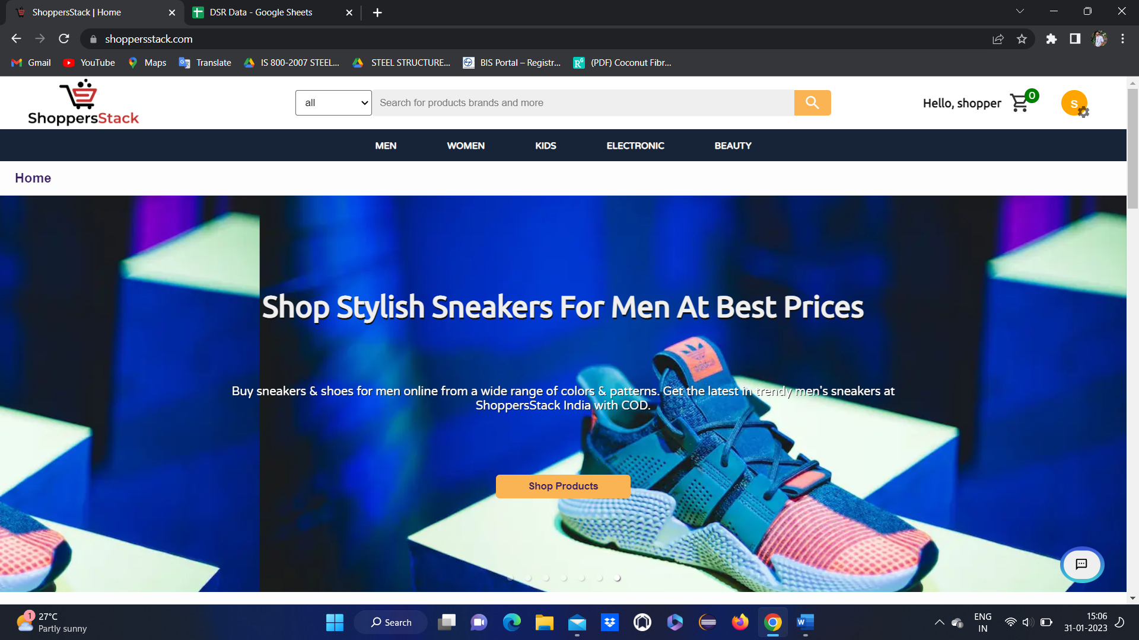

When a user clicks on Electronic, the electronic page will be displayed & following components will be displayed electronic GST store, Cameras, USB cables & accessories, watches, computer hard drives, headphones, laptops, mobile & power banks.

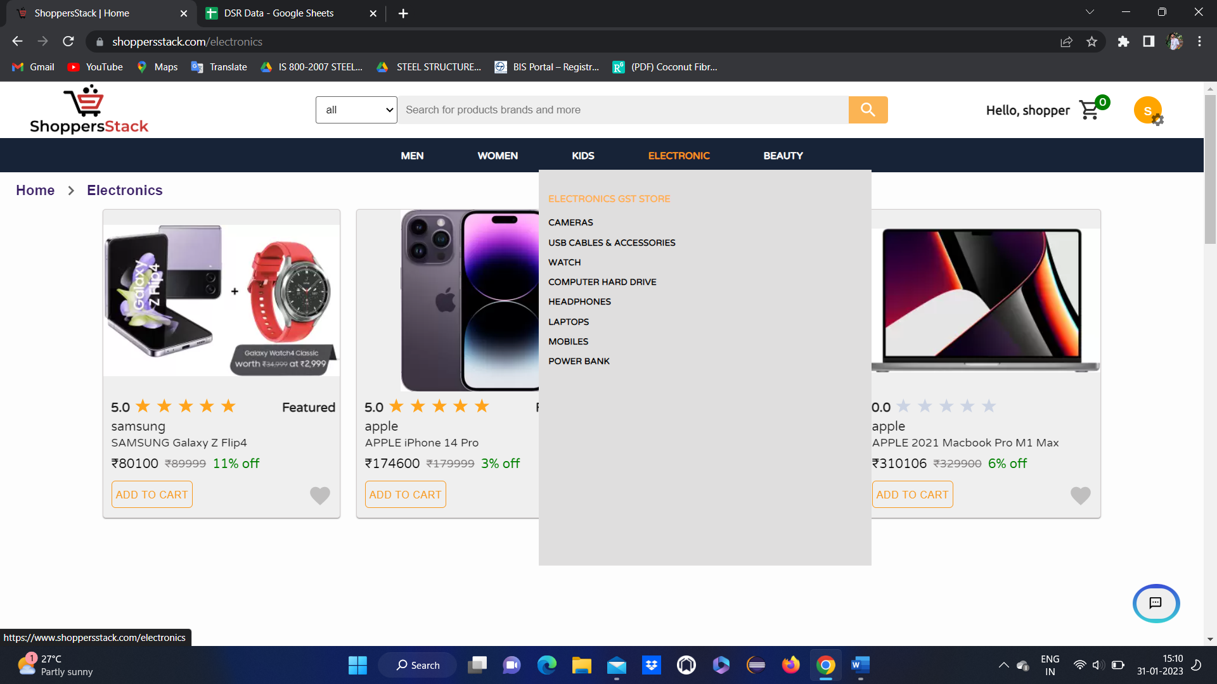

* When users click on electronic & in that if they select cameras, the cameras section will be displayed and the products will be displayed (products tiles will display)

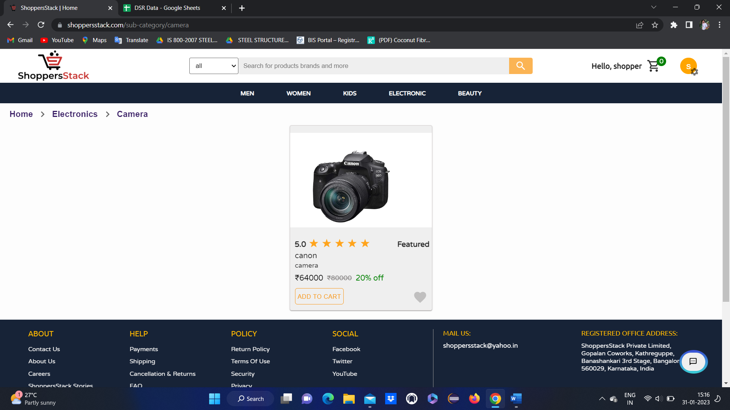

Here user can see

* Product ratings
* Price of the product
* Name of the product
* Discount and original price
* Add to Wishlist

When user clicks on any product🡪product description page will open

With all the information about the product and reviews.

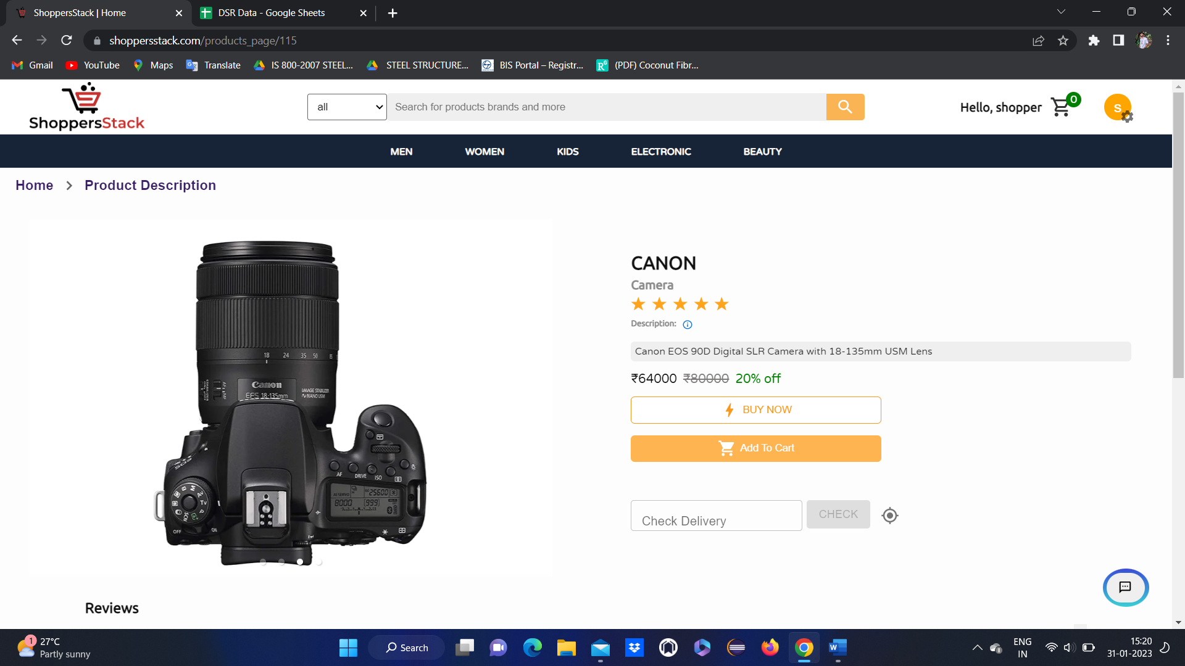

If user is NOT LOGGED IN and if he is trying to do any actions like

Buy now

Add to cart

Add to Wish list etc.. 🡪 lead to **Shopper login** page

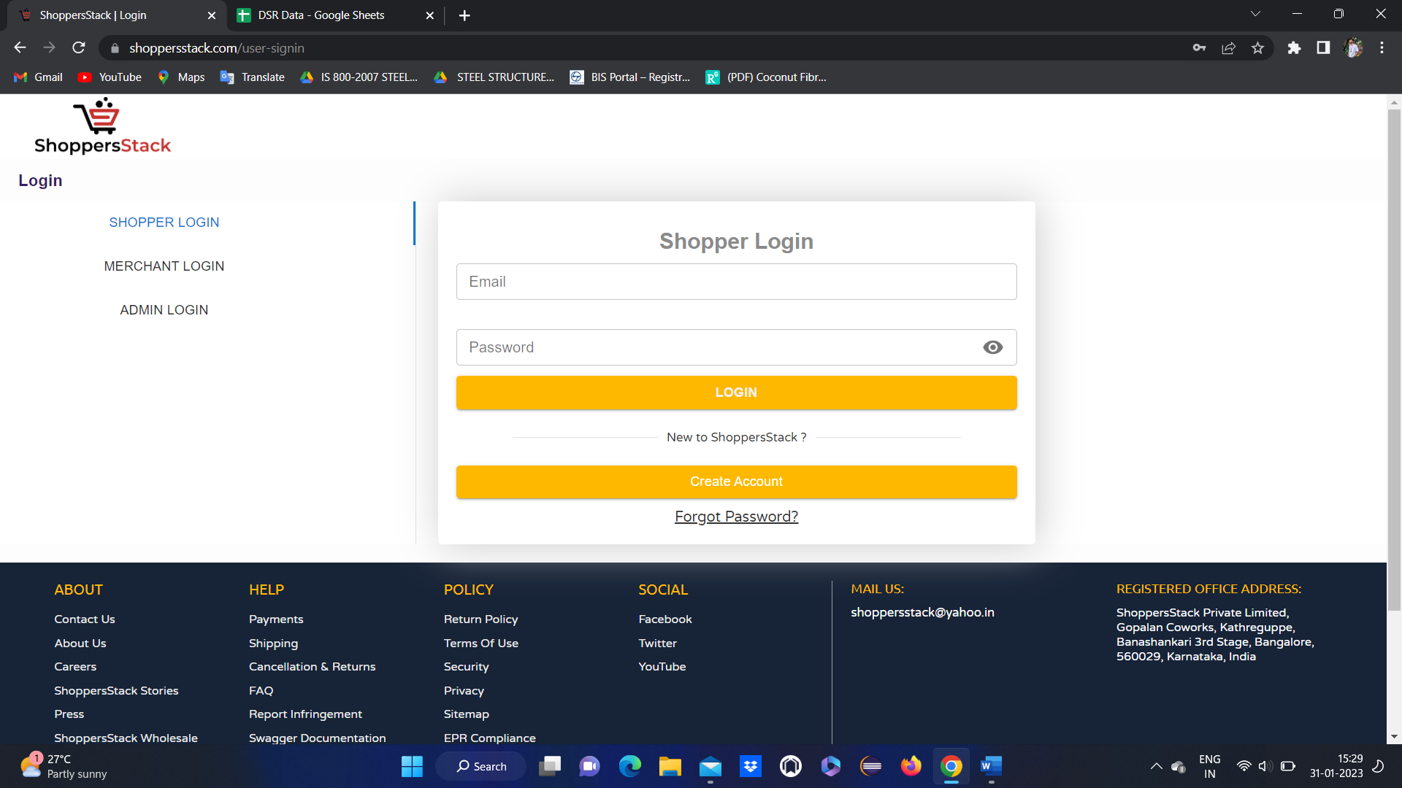

* IF user have an account means have to login by entering registered email and password
* IF user don’t have an account means have to create an account first.

After login

User Home page will be displayed



Again go to respective product page.

1 .When user clicks on COMPARE flipkart page popup is displaying

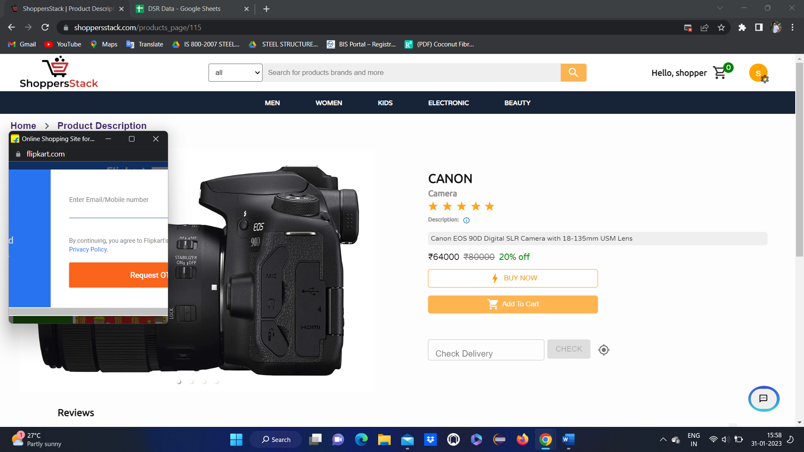

* Where user can compare the products with flipkart products

2 .When user wants to add product to cart has to click on add to cart either in product tile or in product description



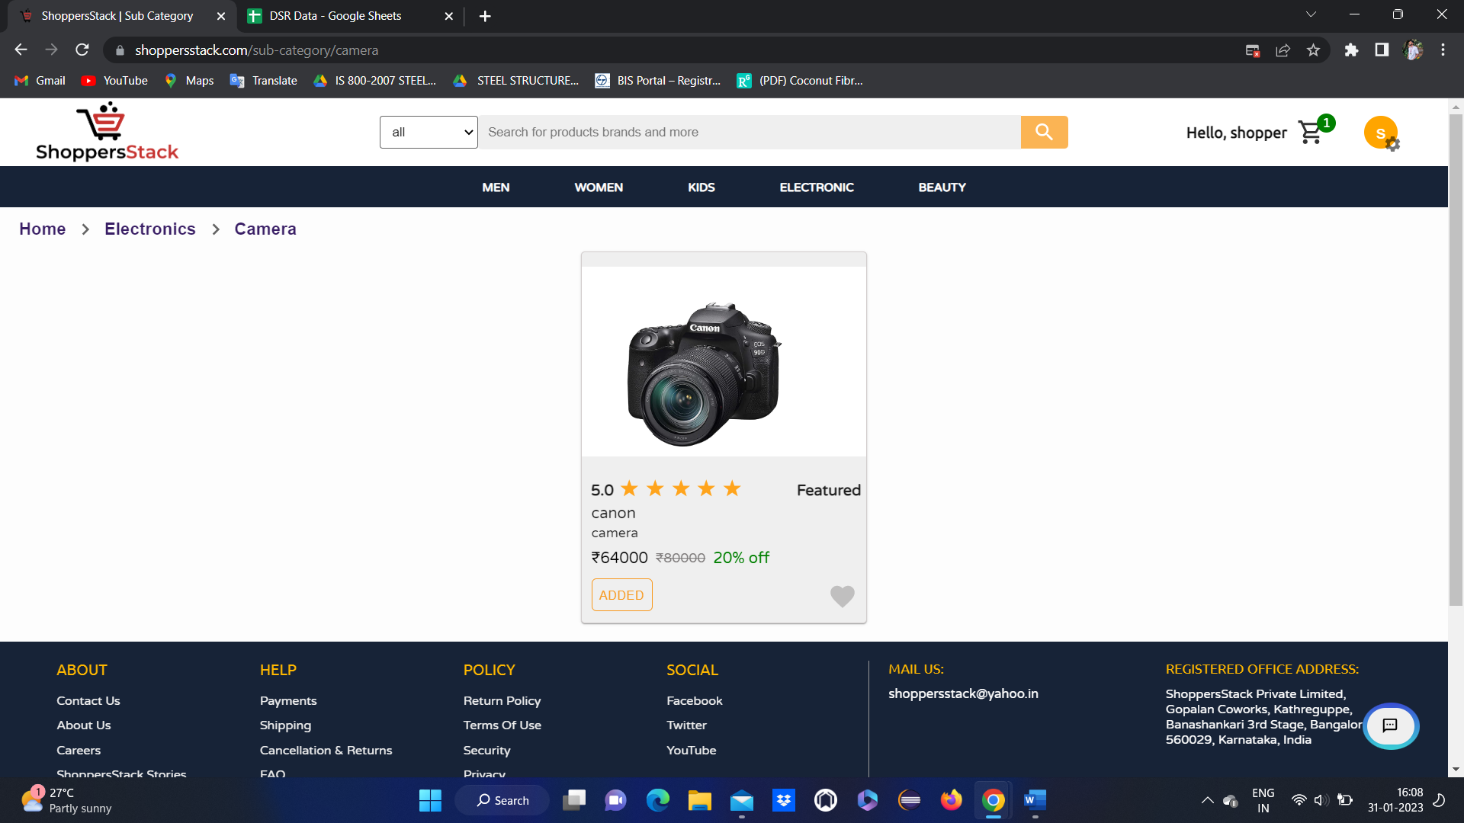

* After clicking on add to cart product will get added to cart.

When the user clicks on the cart symbol

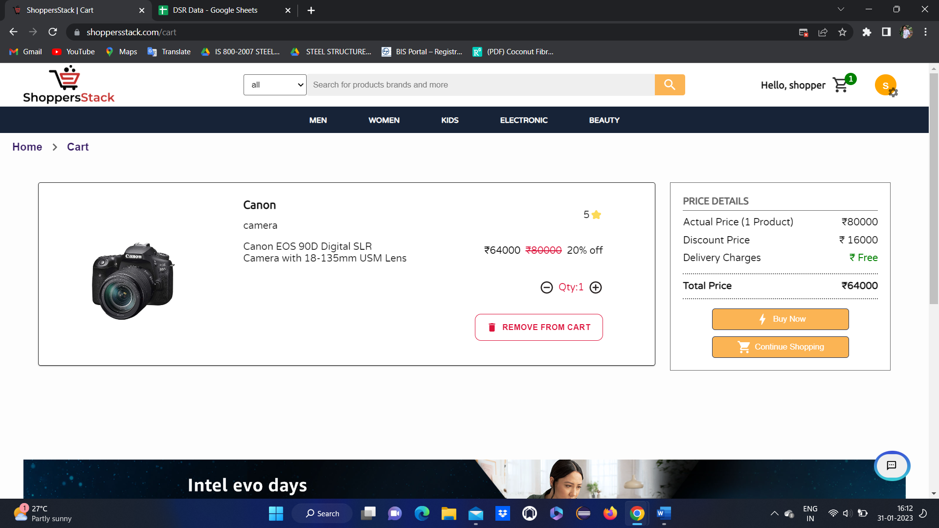

* When the user adds the product to the cart it will display as Added & also in the top left corner we have a cart image where it will be added by displaying the number.
* When the user clicks on the cart symbol added product will be displayed & also it will display details about the product like name, price, offers in percentage, quantity (user can increase and decrease the quantity ) & price details like actual price, discount price, delivery charges & total price.
* **If users want to remove the product from the cart by clicking on the remove from cart button, they can remove it.**



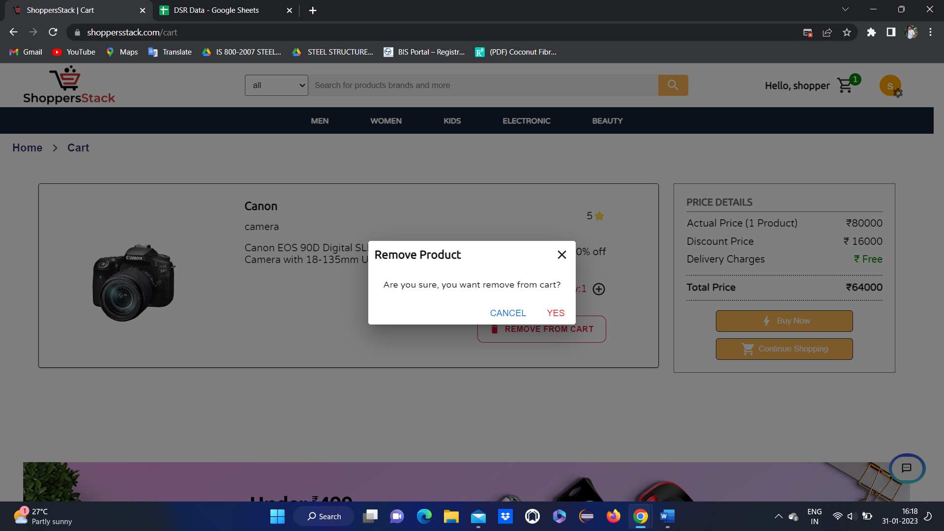

Click on yes

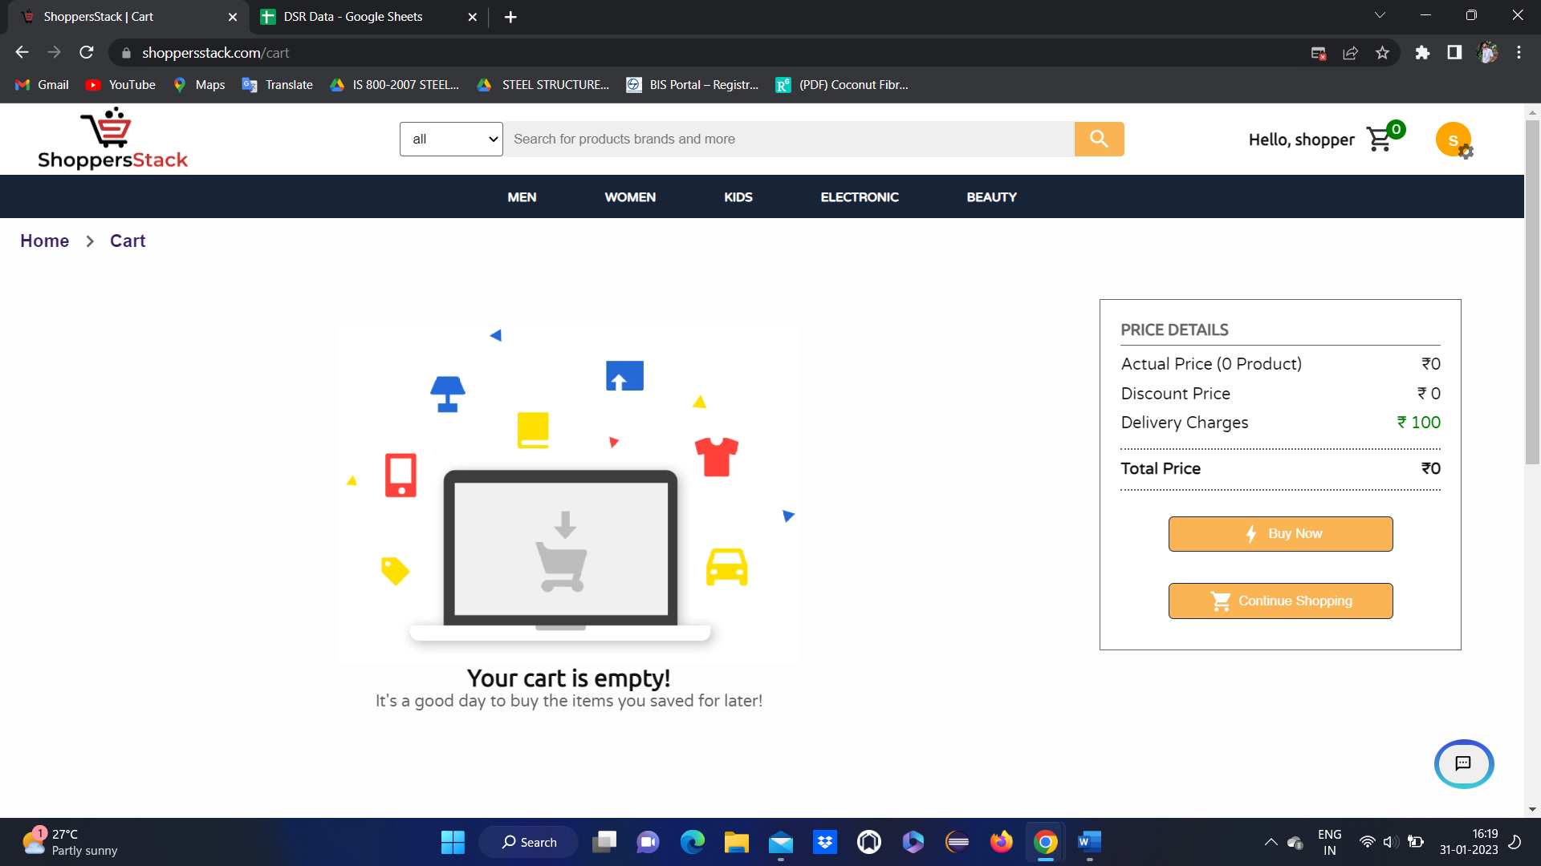

* When the user clicks the on remove from the cart button it will display a lay confirmation message like Cancel or Yes to remove the product if they select “YES” the product will be removed from the cart & product will not be present in the cart module.

3 when user wants to buy the product

Has to click on **buy now** in product description or in cart



* When user clicks on buy now it will goto select delivery address thare user has to add the address

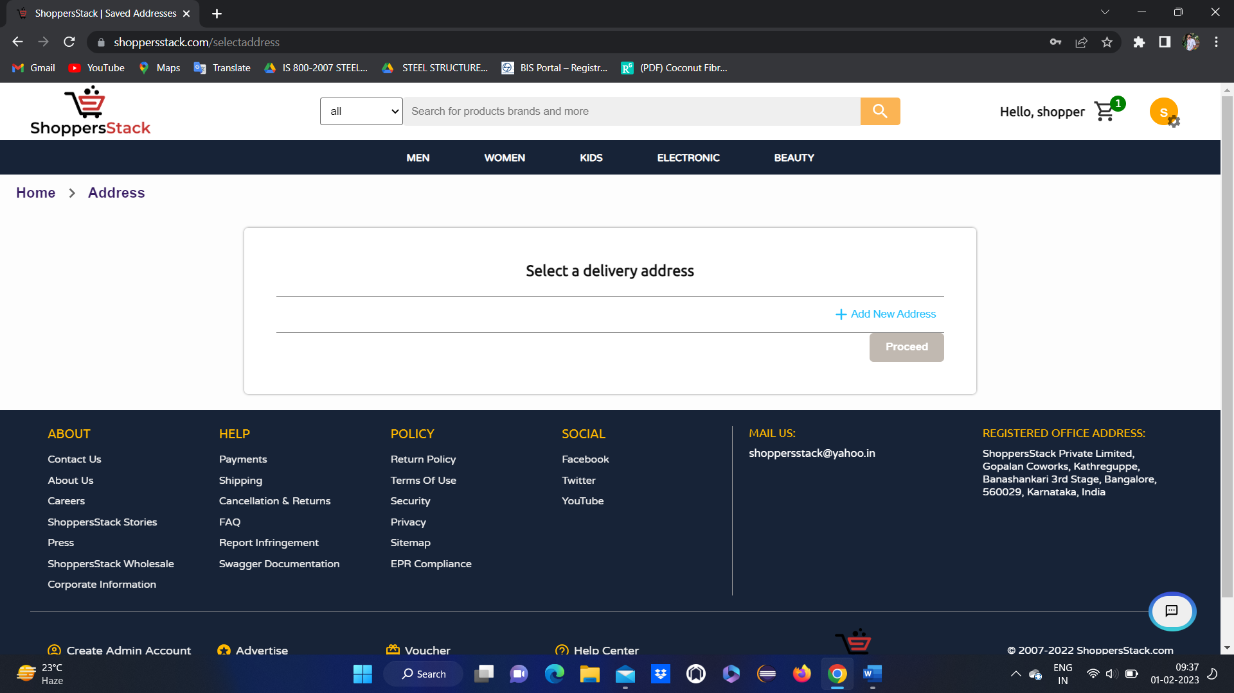

* If user not added any address means user can add the address by clicking on **add new address🡪 add address**

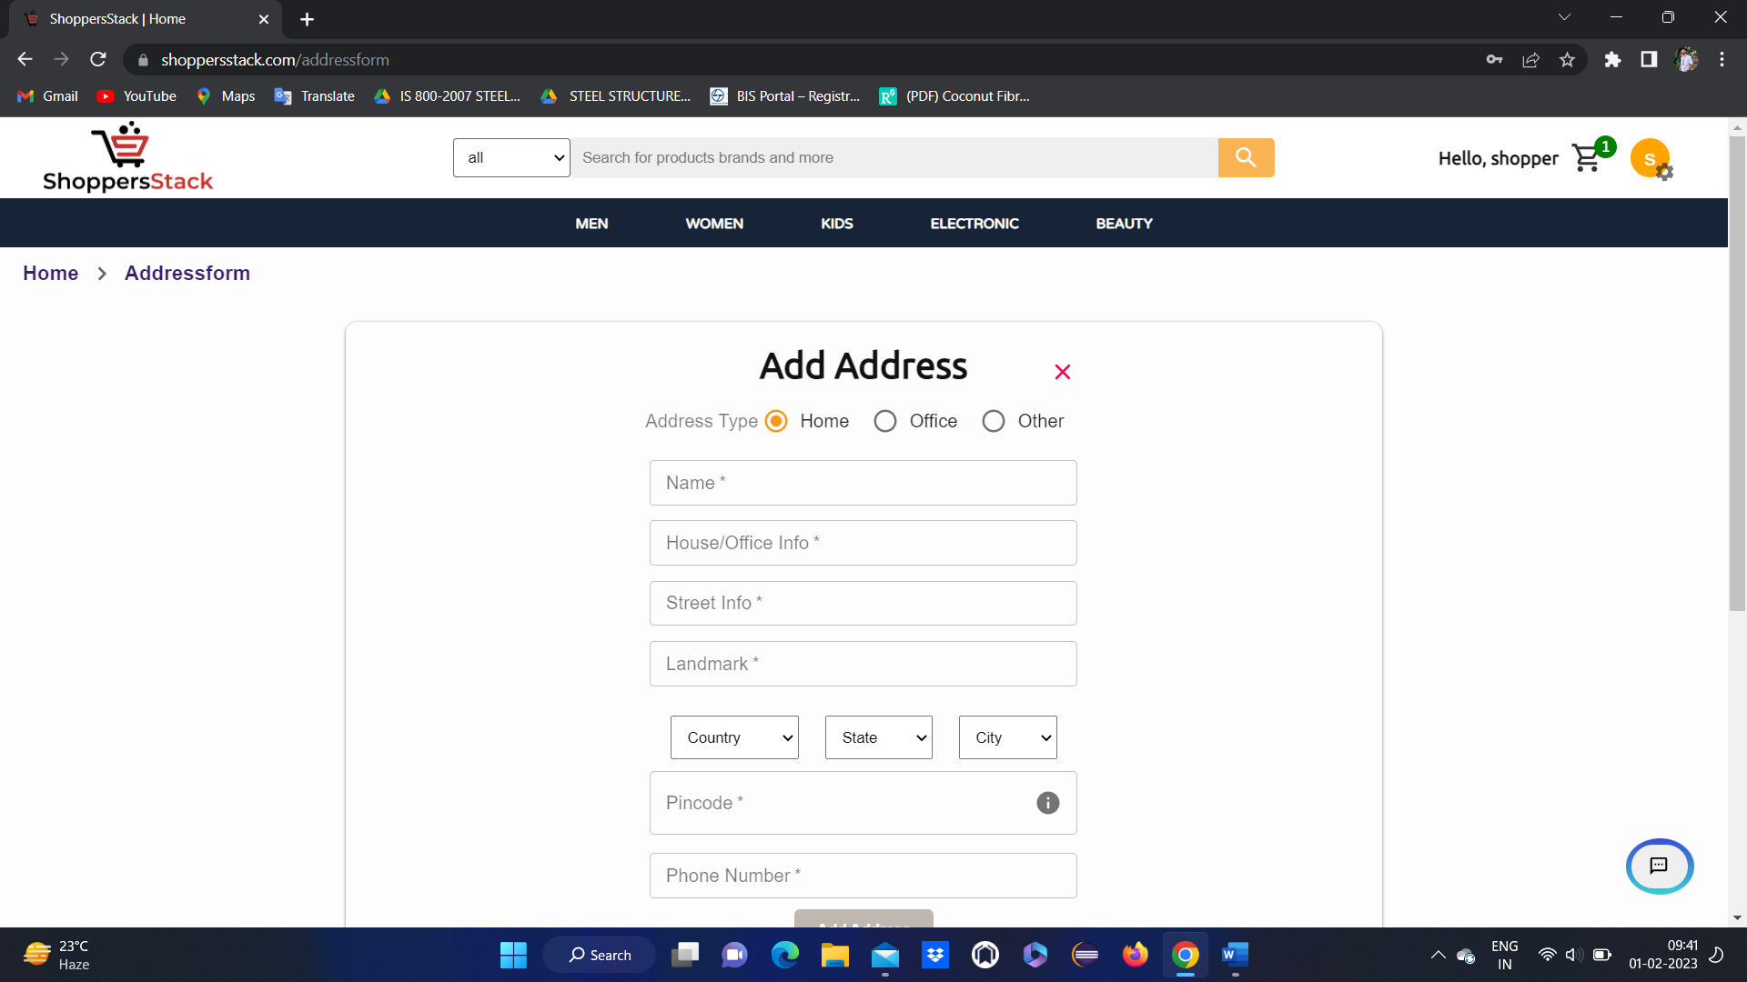

* Here user has to select address type and has to enter name, house info, street info, land mark.
* Select country and state and city
* Enter pincode and phone number

Products are deliverable for some selected pincodes . user can get info about deliverable pins through **deliverable pins** popup.



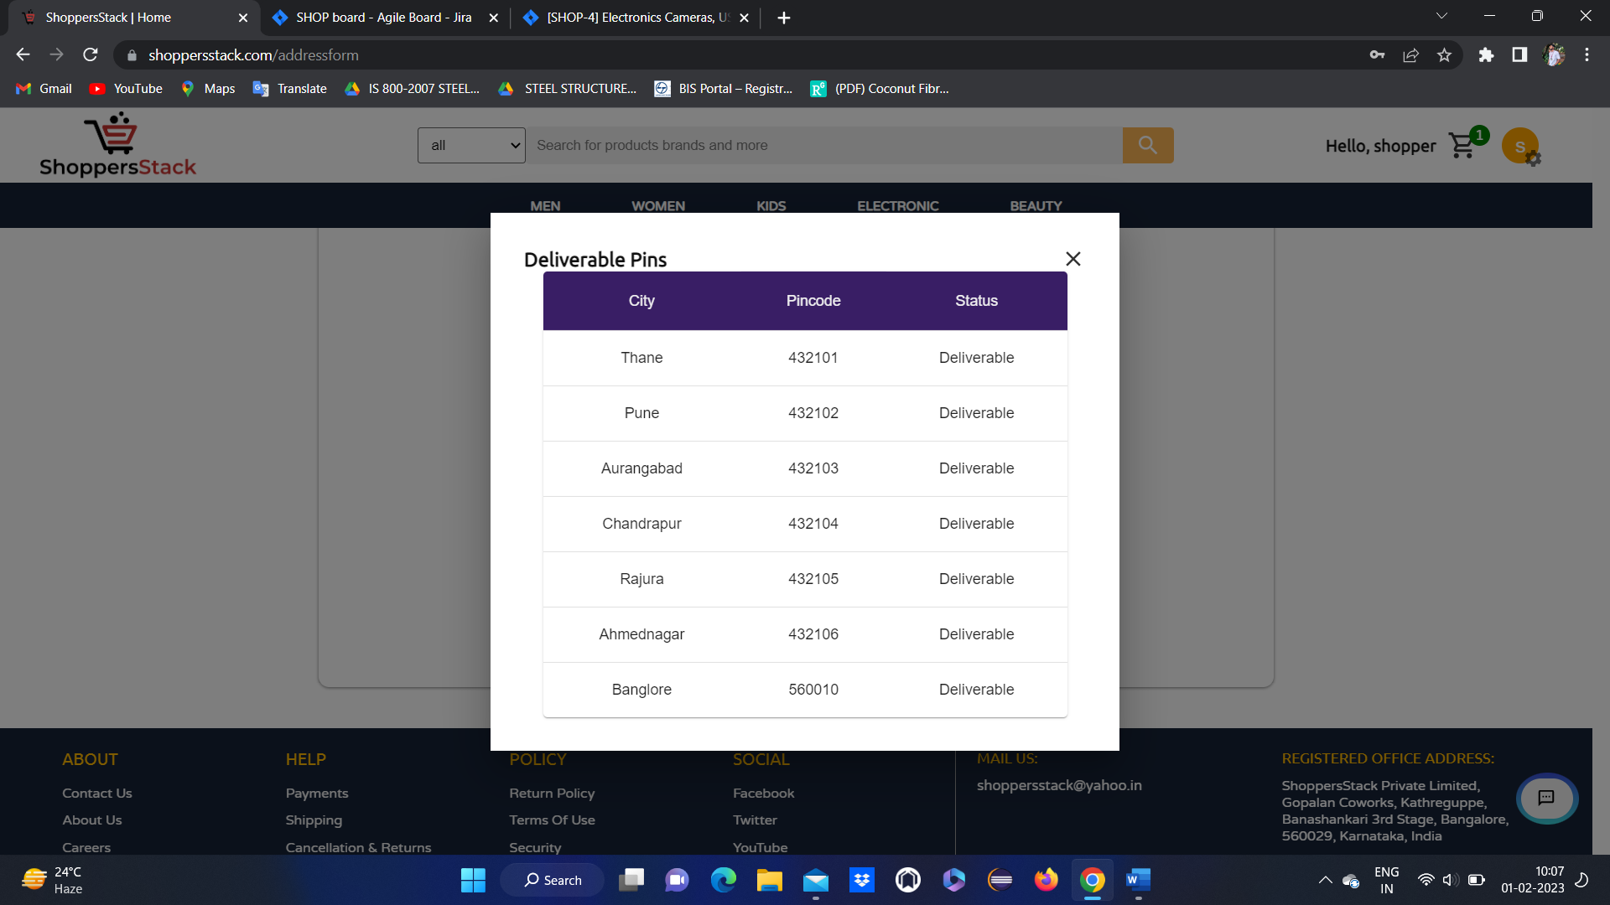

* When a user entered all the details for the address it will add to the list of addresses & user will a get popup message (successfully added) then the user will once again select the address where they want their product to deliver.

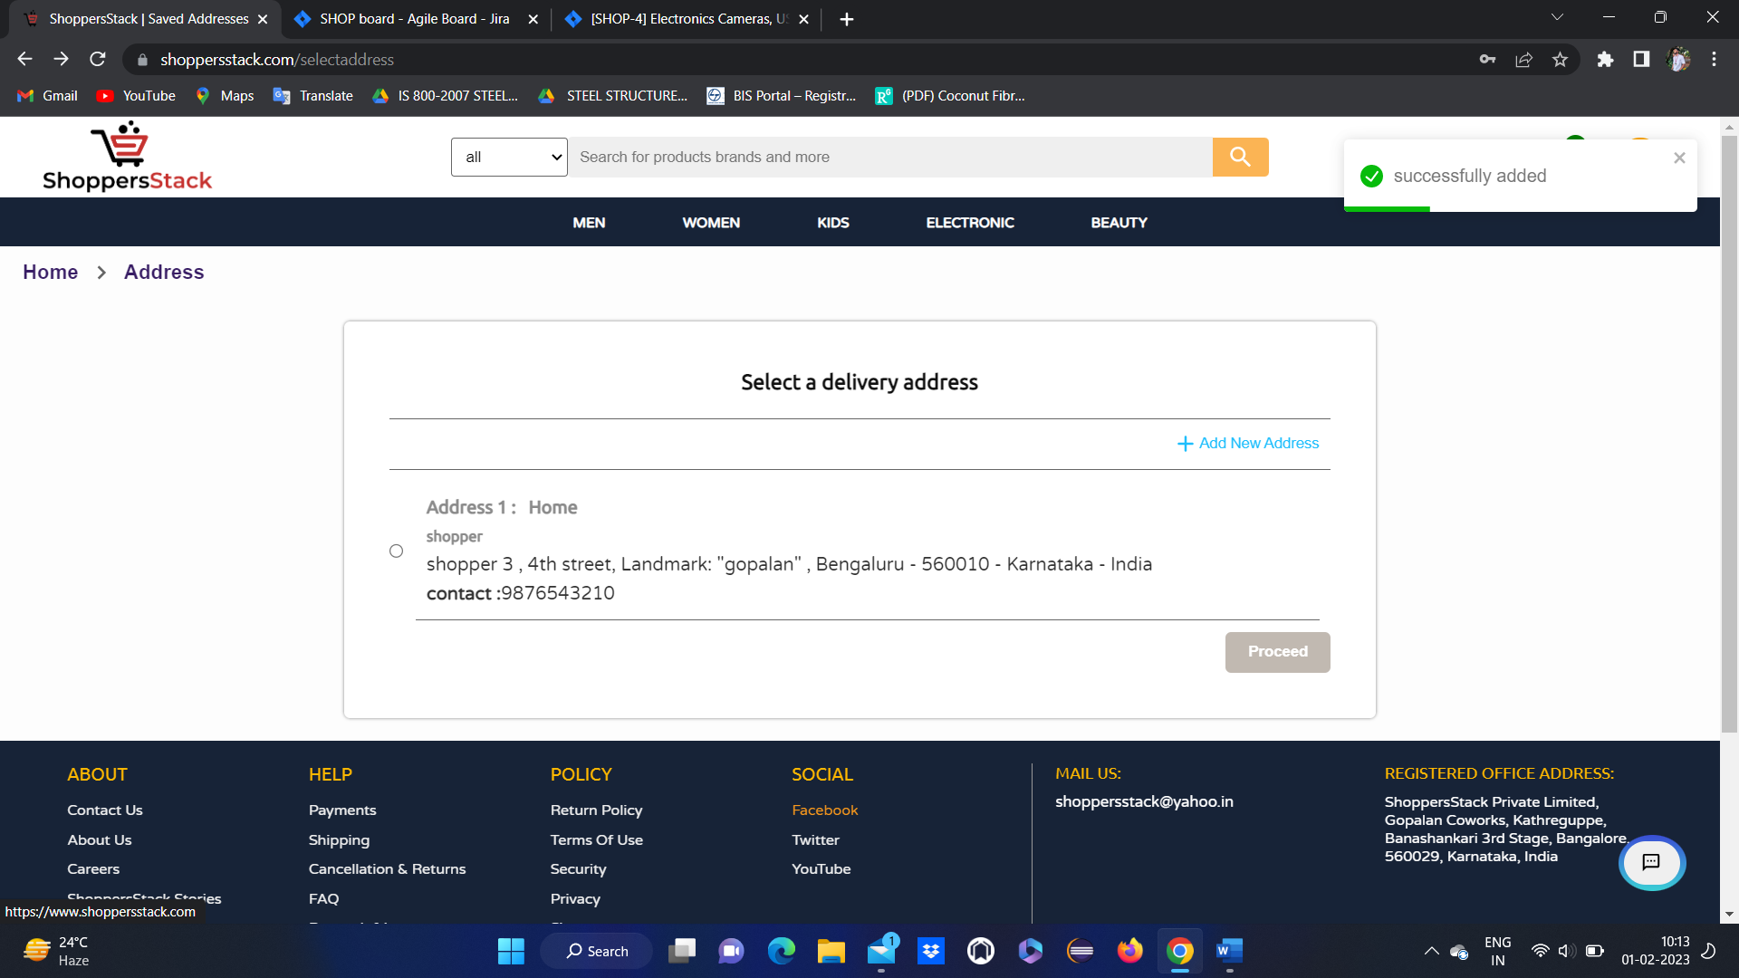

* once again user has to select the address where they want their product to deliver and click on proceed.
* It will go to select payment option method page with the following functionalities like net banking, cash on delivery (COD) & add a card.

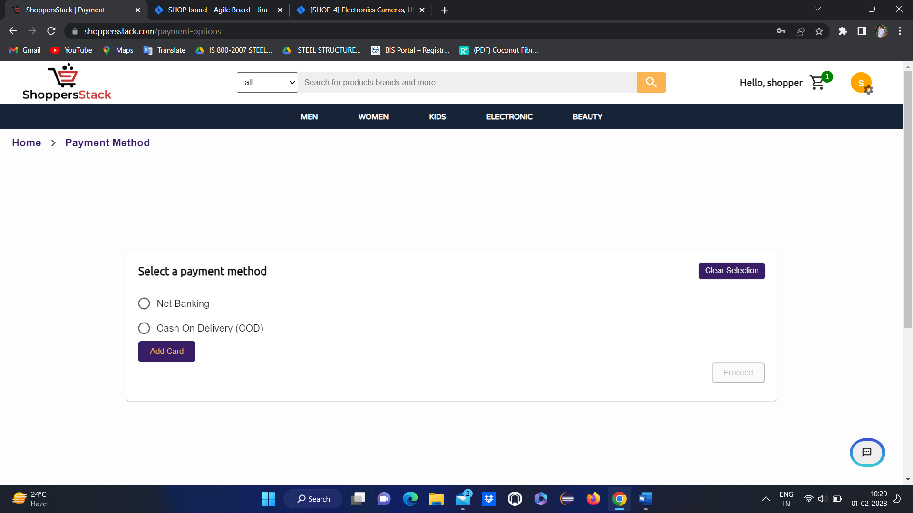

* If user selects **net banking** and click on procced . it will go to select bank page
* Here user has to select an option out of the available options like TDFC,

TCICI,TBI, IDHC and click on submit

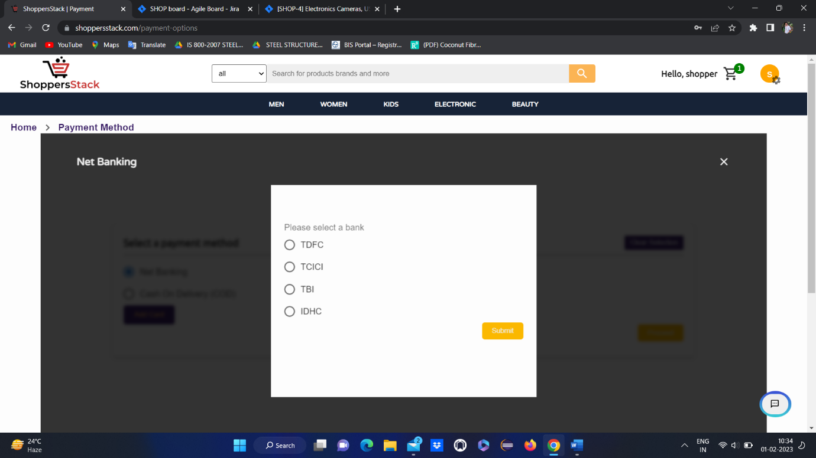

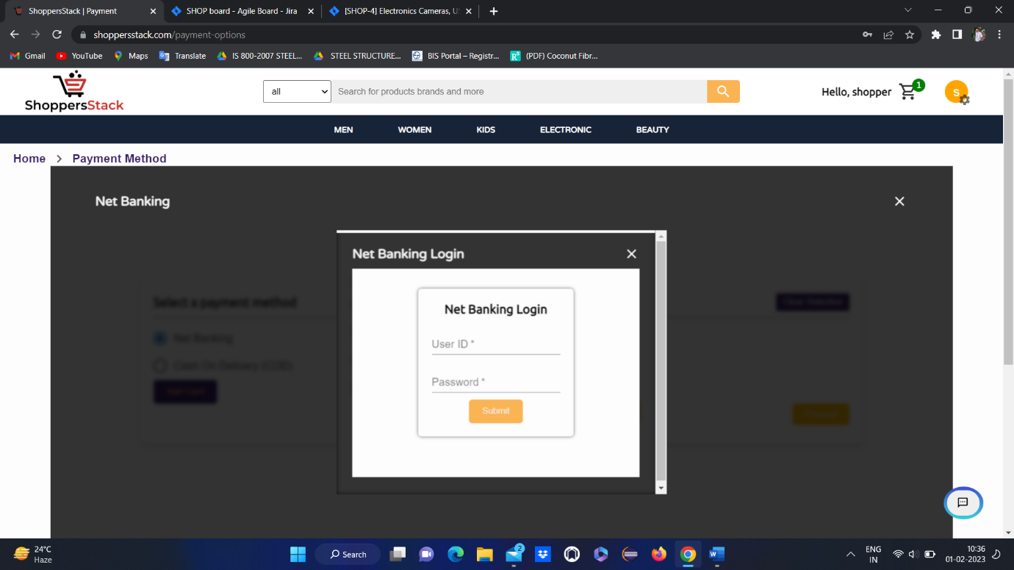

* After selecting a bank user will go to the net banking login page
* Here user has to enter valid user ID and password and click on submit
* If the user has an invalid User ID & password it will display Invalid bank account credentials, then the user can’t able to complete the payment.
* After login user should click on pay now it will display order confirmation page

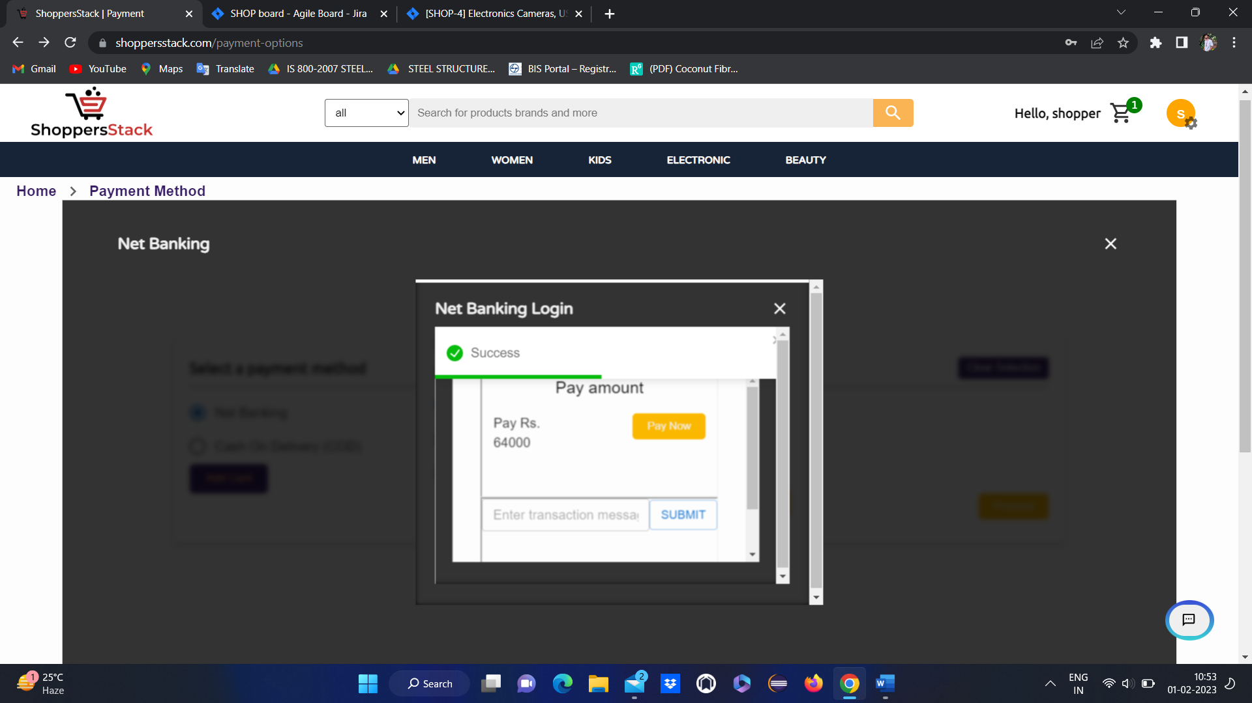

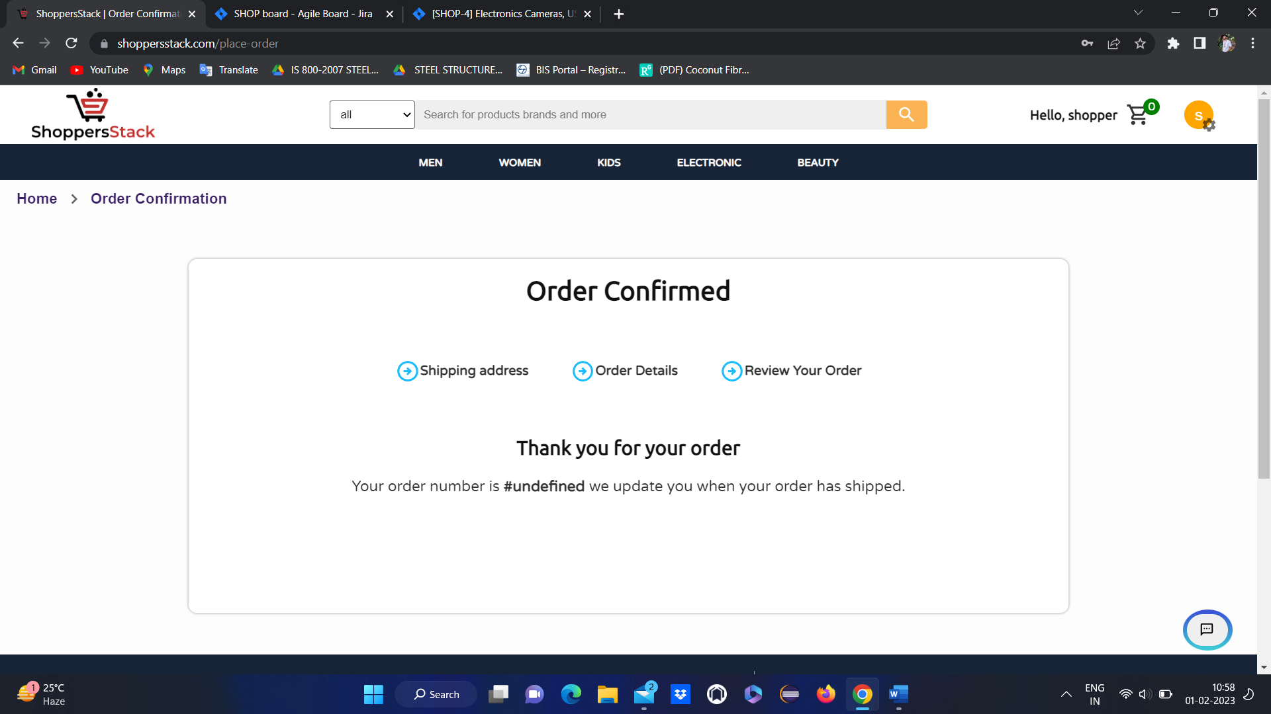

* if user selects **cash on** **delivery** and click on proceed order will be confirmed.



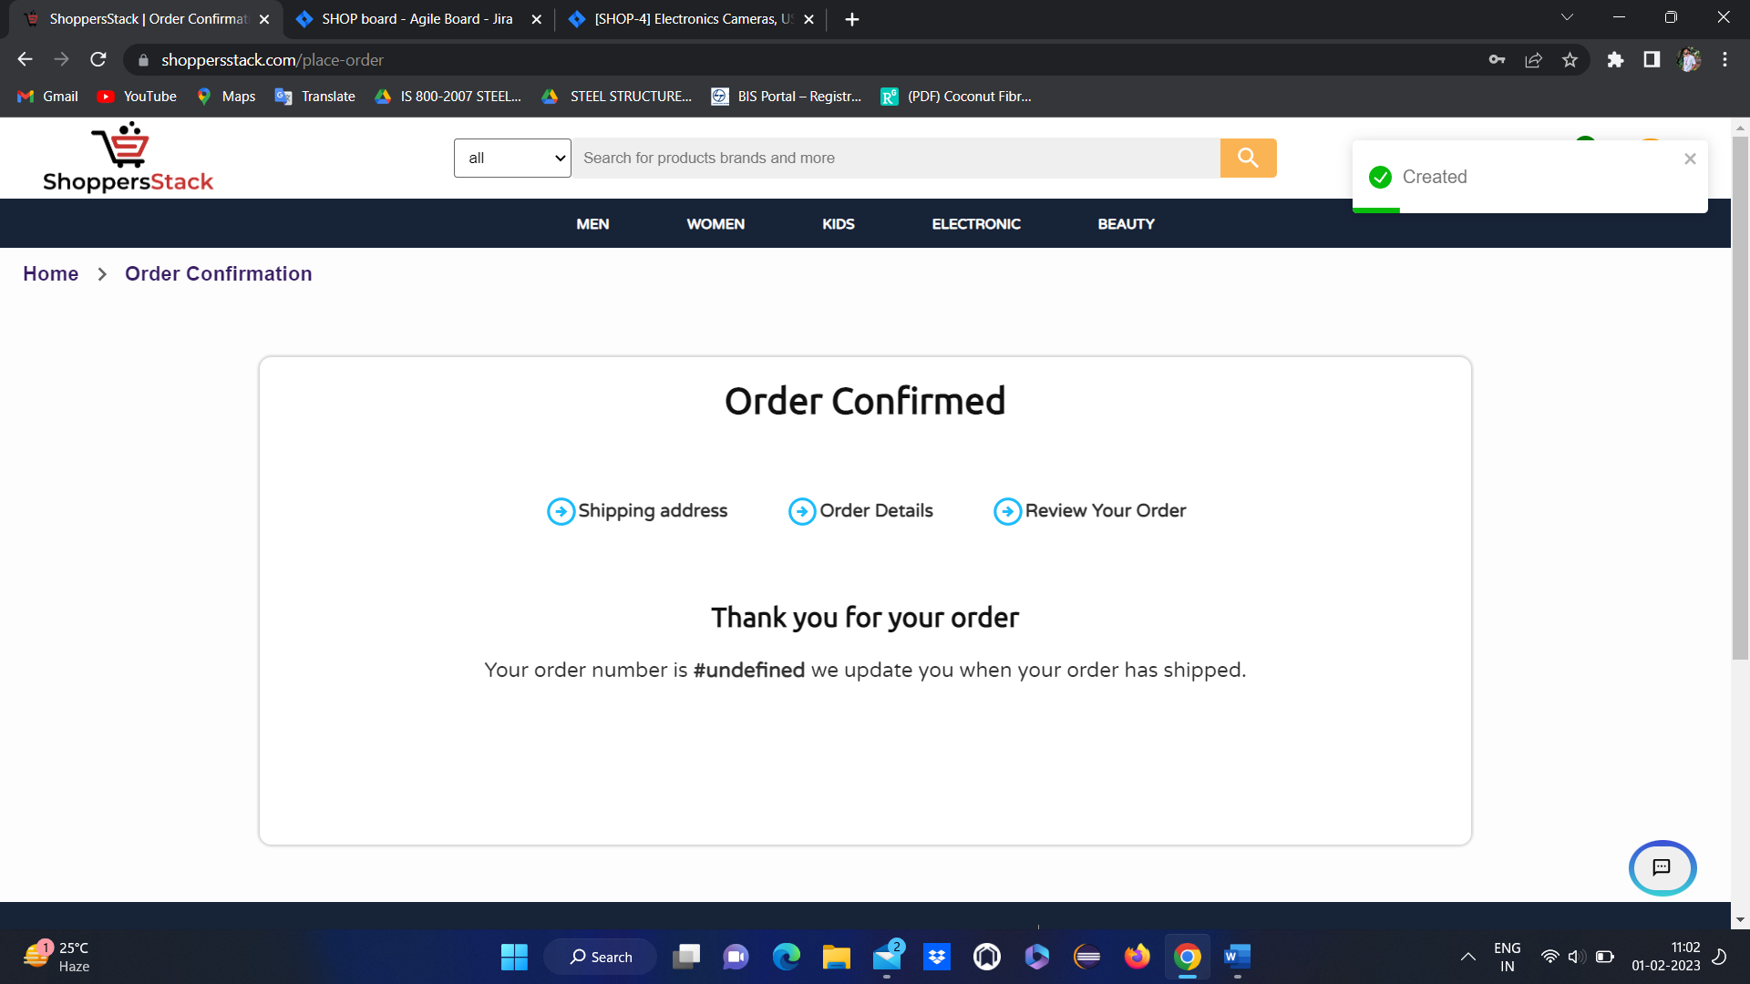

* If user wants to pay through card
* User has to add the card by clicking on add card
* It will go to add card page



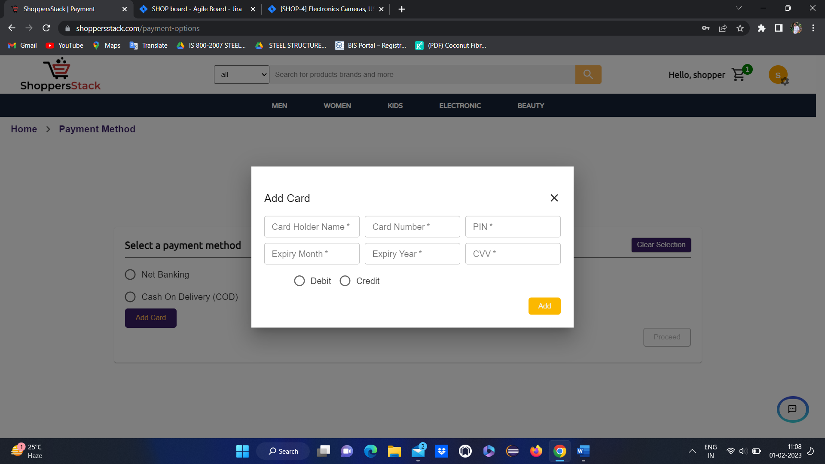

* User has to enter valid data for all the fields like **cardholder name, card number, PIN, expiry month, expiry year, CVV, Debit or Credit options** and has to click on add

4 if user wants to add the product to wishlist



* By clicking on the above icon . user can add the product to wish list

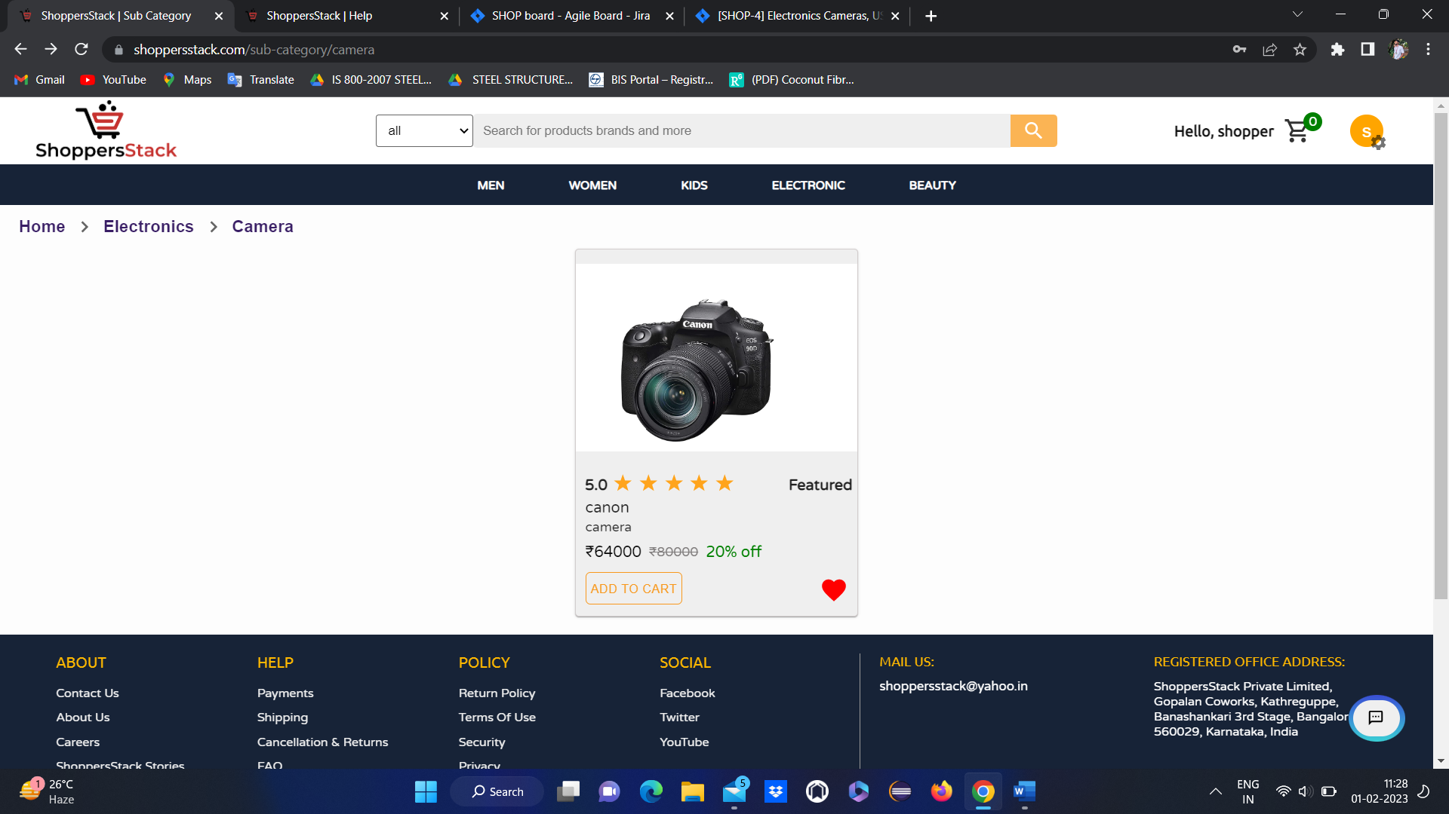

* If user adds any product to wishlist it will be visible in wishlist page
* Click on Profile 🡪wishlist🡪 user is able to see the products in wish list

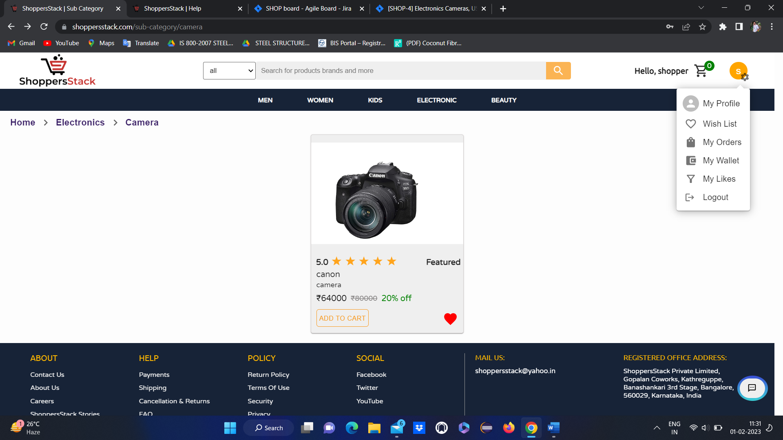

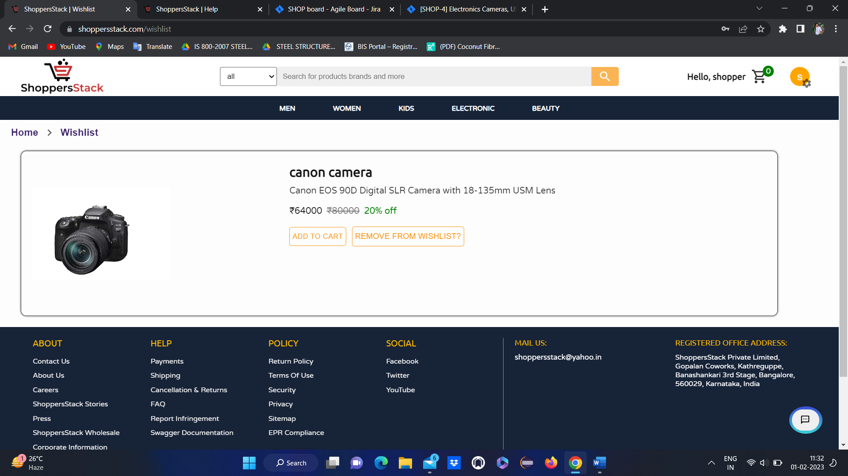

* When users click on electronic & in that if they select USB cables and Accessories, the USB cables and Accessories section will be displayed and the products will be displayed.

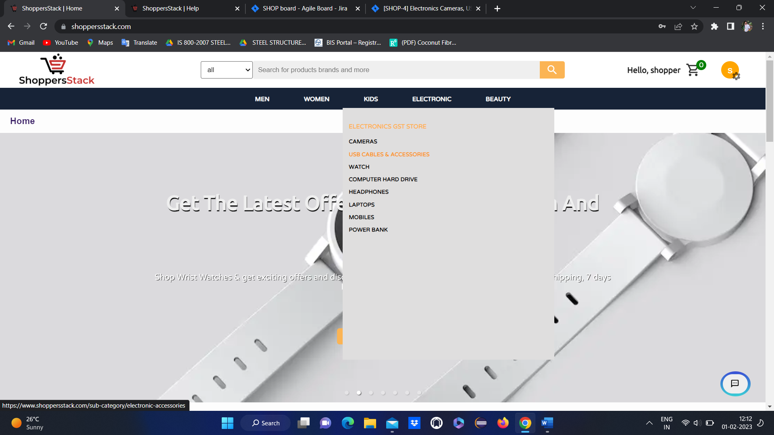

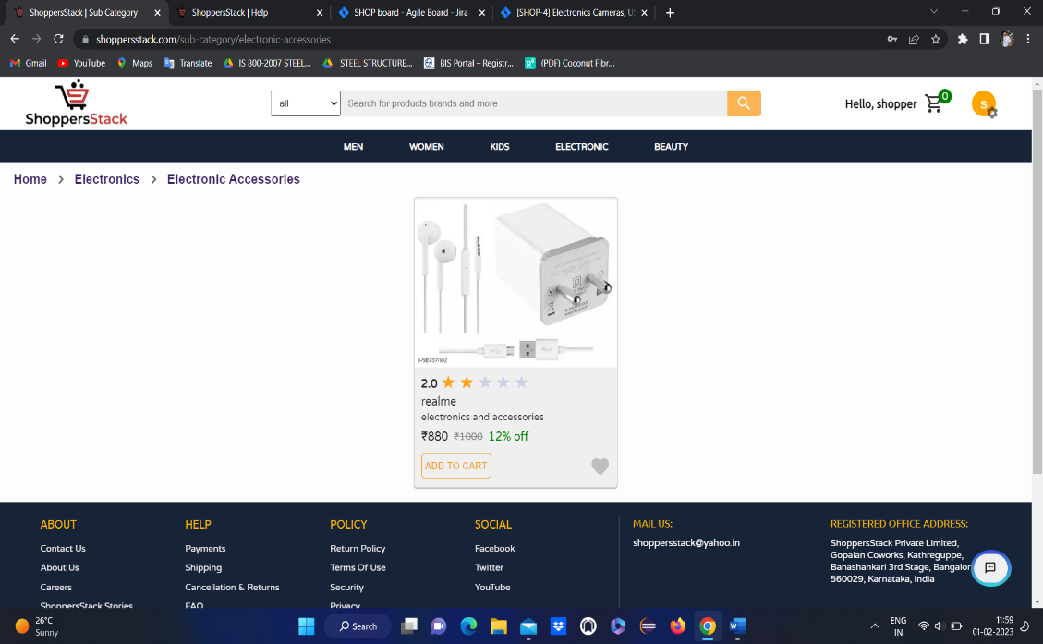

Here user can see

* Product ratings
* Price of the product
* Name of the product
* Discount and original price
* Add to Wishlist

When user clicks on any product🡪product description page will open

With all the information about the product and reviews.

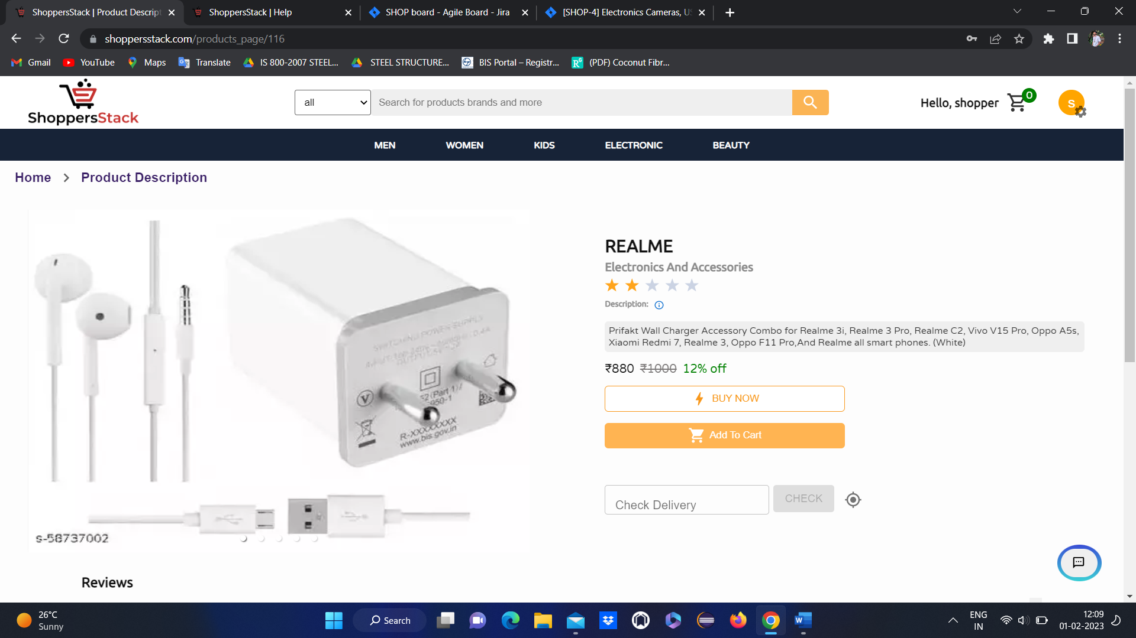

If user wants to perform actions like

Buy now

Add to cart

Add to Wish list etc..

User should be logged in

If user is NOT LOGGED IN and if he is trying to do any actions like

Buy now

Add to cart

Add to Wish list etc.. 🡪 lead to **Shopper login** page



* IF user have an account means have to login by entering registered email and password
* IF user don’t have an account means have to create an account first.

After login

User Home page will be displayed



Again go to respective product page.

1 .When user clicks on COMPARE flipkart page popup is displaying

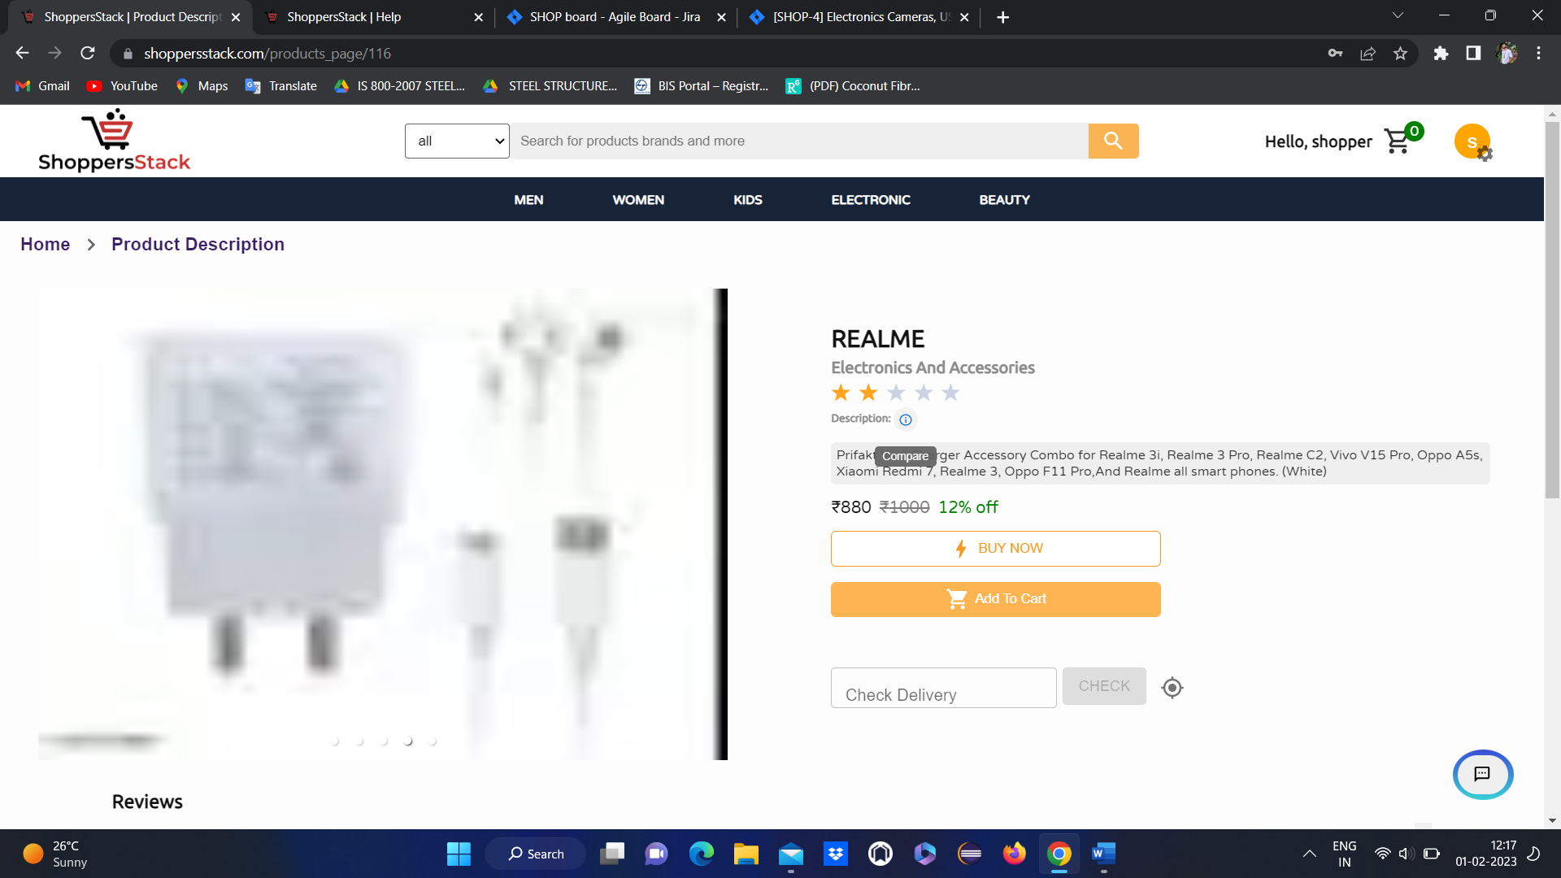

* Where user can compare the products with flipkart products

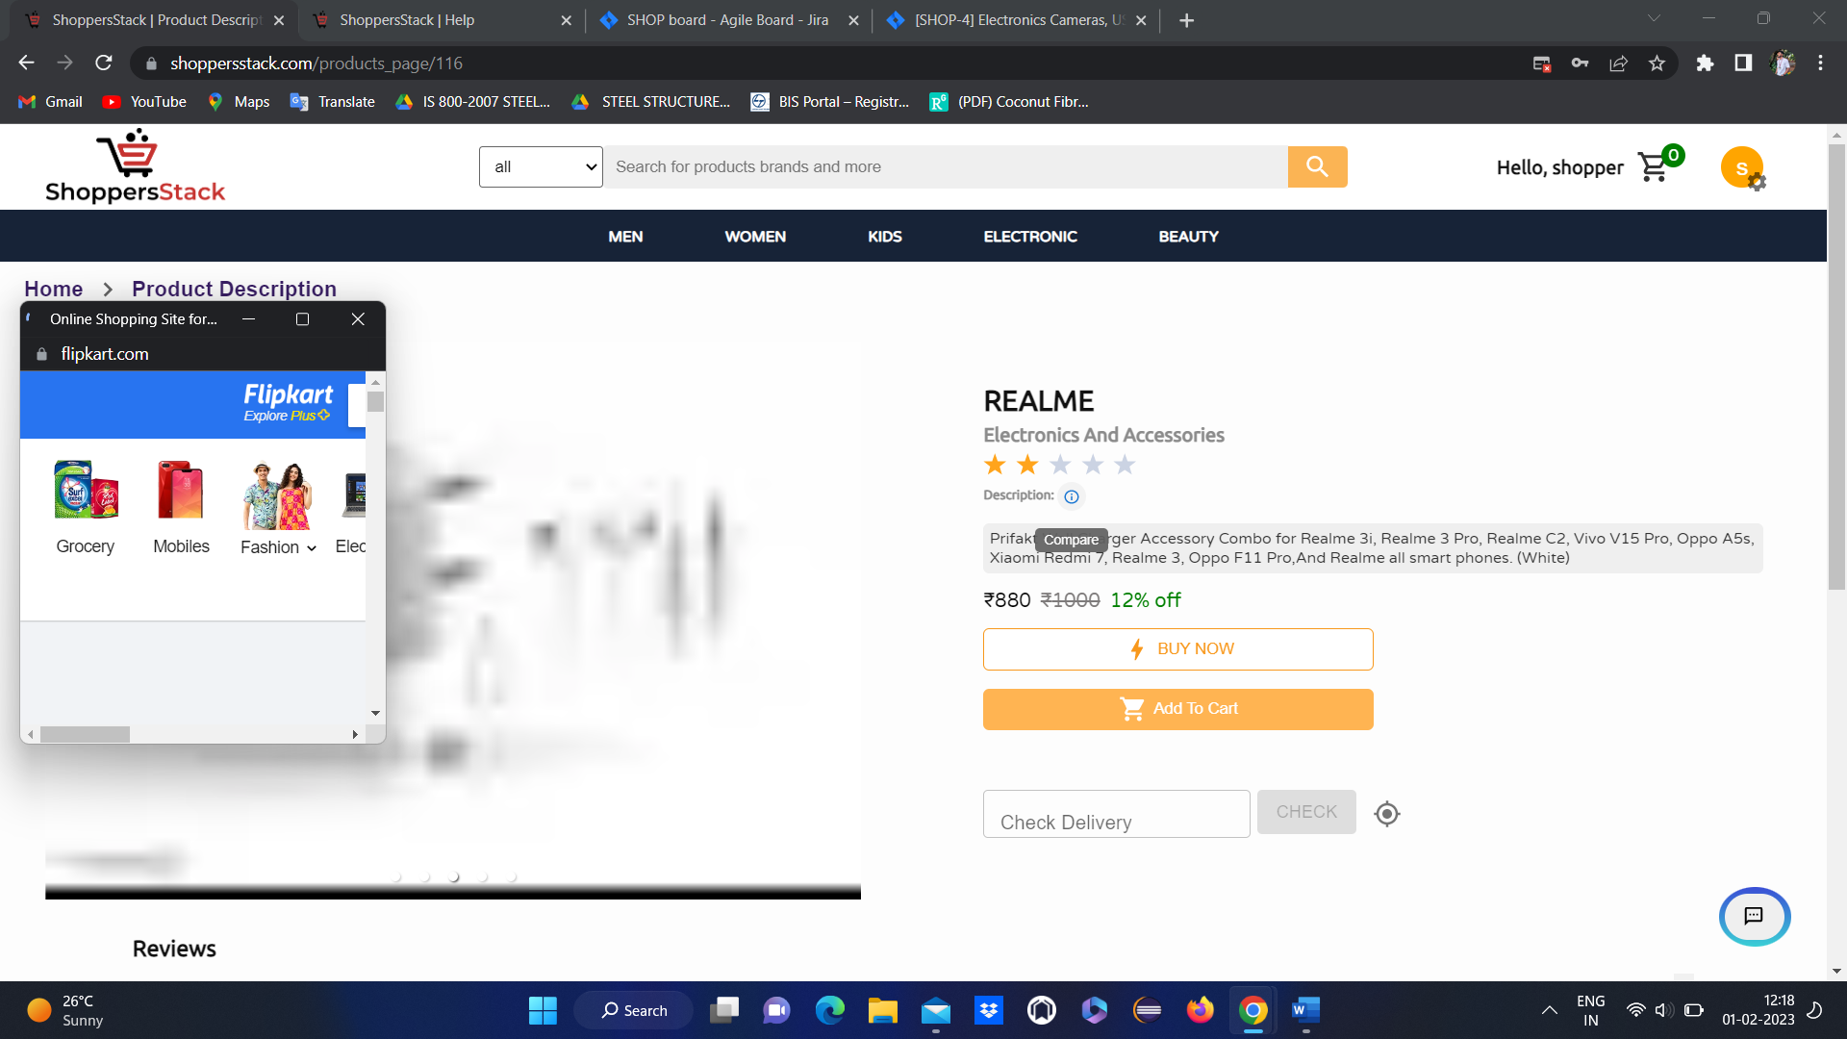

2 .When user wants to add product to cart has to click on add to cart either in product tile or in product description



* After clicking on add to cart product will get added to cart.

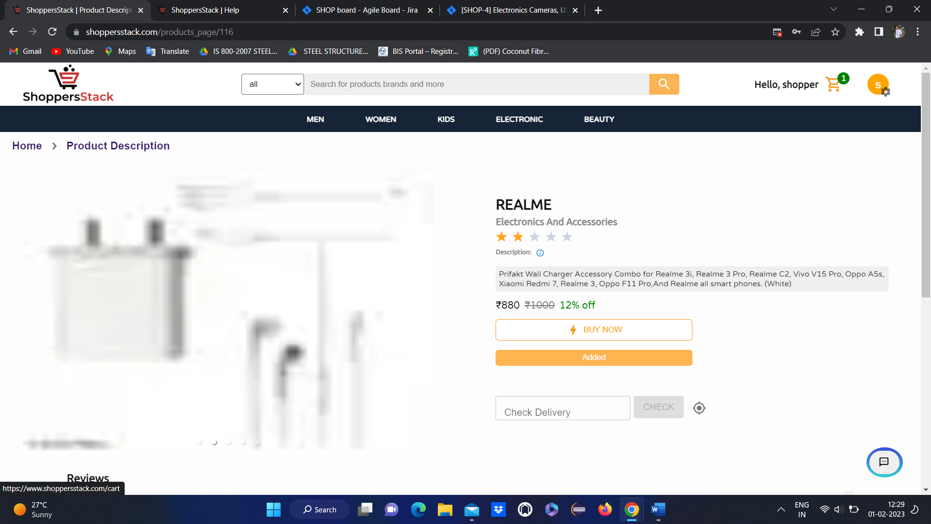

When the user clicks on the cart symbol

* When the user adds the product to the cart it will display as Added & also in the top left corner we have a cart image where it will be added by displaying the number.
* When the user clicks on the cart symbol added product will be displayed & also it will display details about the product like name, price, offers in percentage, quantity (user can increase and decrease the quantity ) & price details like actual price, discount price, delivery charges & total price.

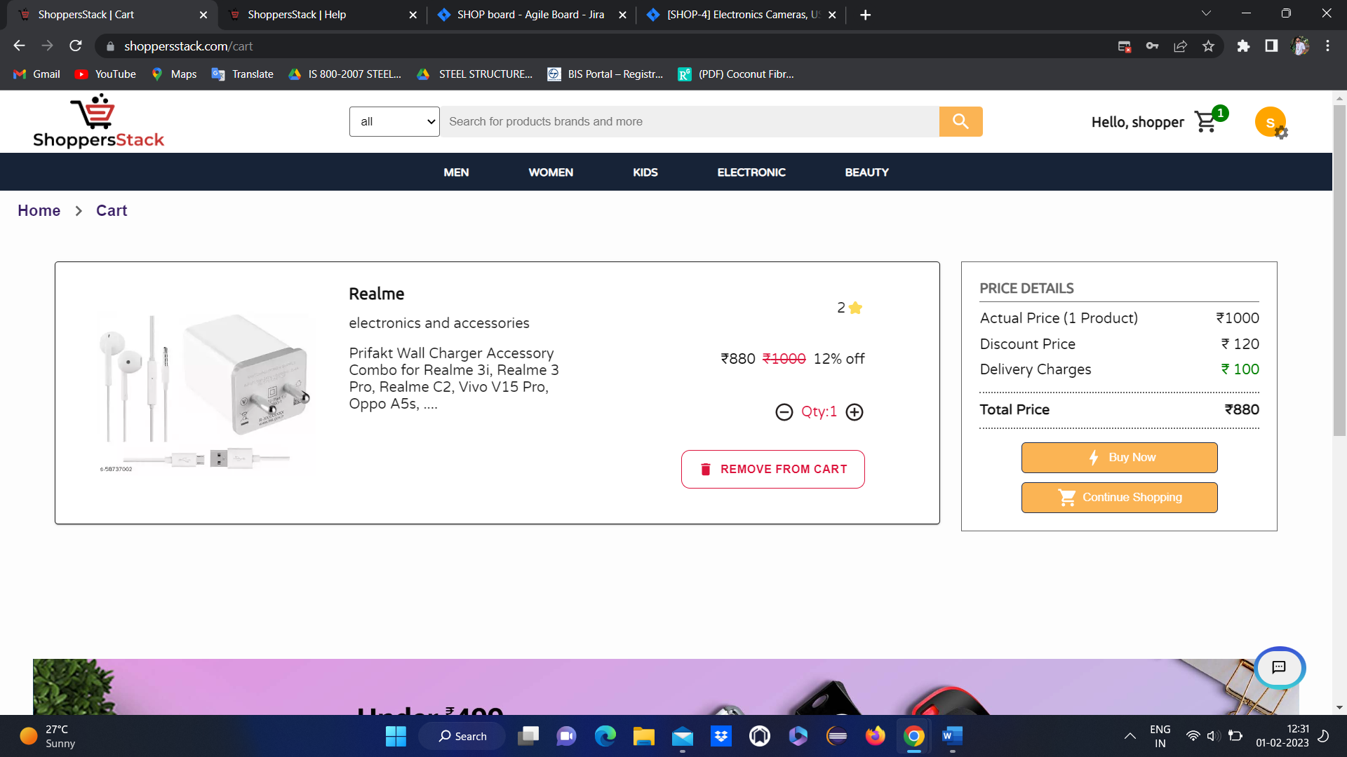

* **If users want to remove the product from the cart by clicking on the remove from cart button, they can remove it**



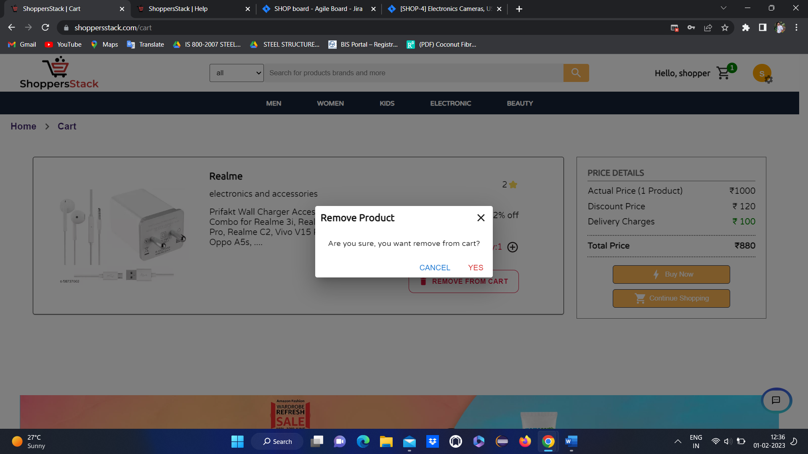

Click on YES

* Product will be deleted and an empty cart will display.



**3 when user wants to buy the product**

Has to click on **buy now** in product description or in cart



* When user clicks on buy now it will goto select delivery address thare user has to add the address
* **NOTE**—if user have an address already means directly it will lead to this page
* If user wants to add another address means . he can add through **+add new address**



* If user not added any address means user can add the address by clicking on **add new address🡪 add address**



* Here user has to select address type and has to enter name, house info, street info, land mark.
* Select country and state and city
* Enter pincode and phone number

Products are deliverable for some selected pincodes . user can get info about deliverable pins through **deliverable pins** popup.





* When a user entered all the details for the address it will add to the list of addresses & user will a get popup message (successfully added) then the user will once again select the address where they want their product to deliver.



* once again user has to select the address where they want their product to deliver and click on proceed.
* It will go to select payment option method page with the following functionalities like net banking, cash on delivery (COD) & add a card.



* If user selects **net banking** and click on procced . it will go to select bank page
* Here user has to select an option out of the available options like TDFC,

TCICI,TBI, IDHC and click on submit





* After selecting a bank user will go to the net banking login page
* Here user has to enter valid user ID and password and click on submit
* If the user has an invalid User ID & password it will display Invalid bank account credentials, then the user can’t able to complete the payment.
* After login user should click on pay now it will display order confirmation page





* if user selects **cash on** **delivery** and click on proceed order will be confirmed.





* If user wants to pay through card
* User has to add the card by clicking on add card
* It will go to add card page





* User has to enter valid data for all the fields like **cardholder name, card number, PIN, expiry month, expiry year, CVV, Debit or Credit options** and has to click on add
* When users click on electronic & in that if they select WATCH, the WATCH section will be displayed and the products will be displayed.

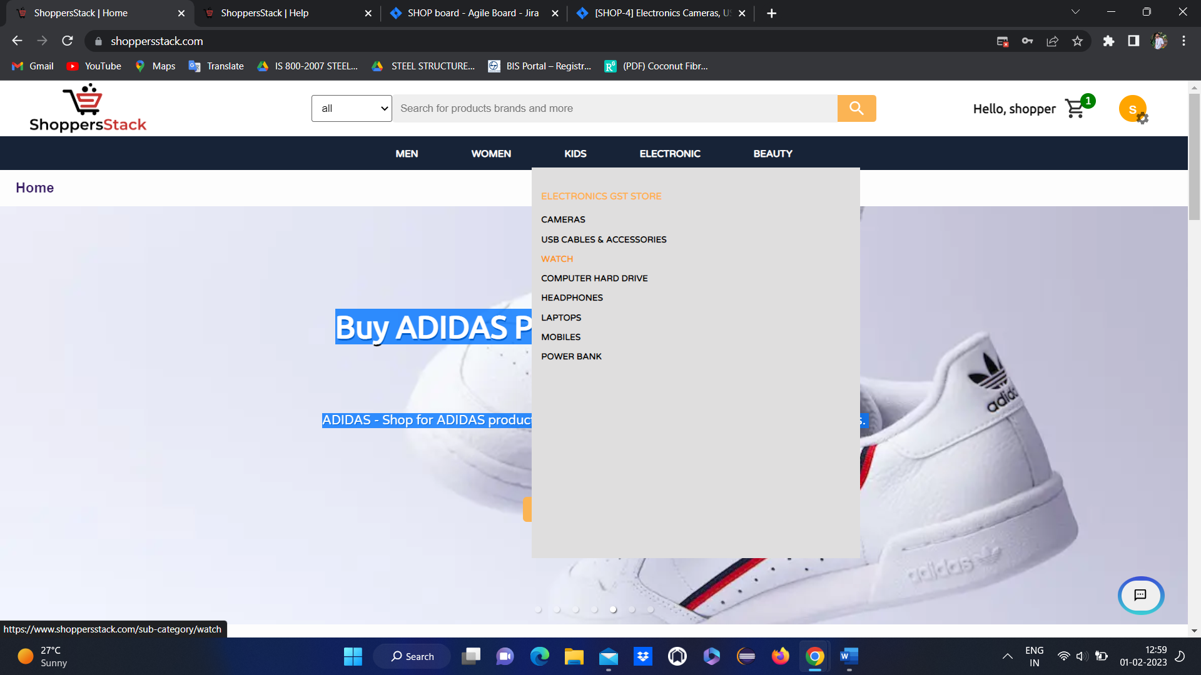

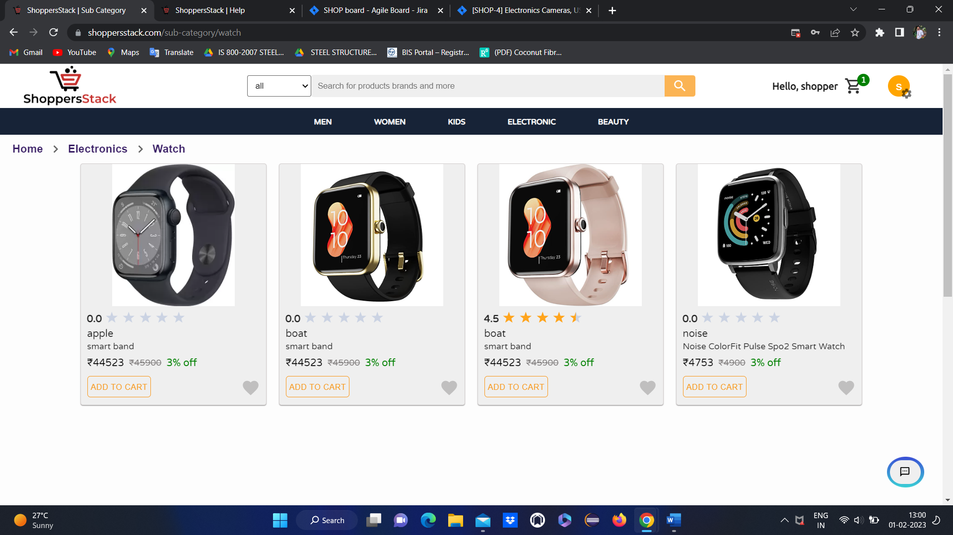

Here user can see

* Product ratings
* Price of the product
* Name of the product
* Discount and original price
* Add to Wishlist

When user clicks on any product🡪product description page will open

With all the information about the product and reviews.

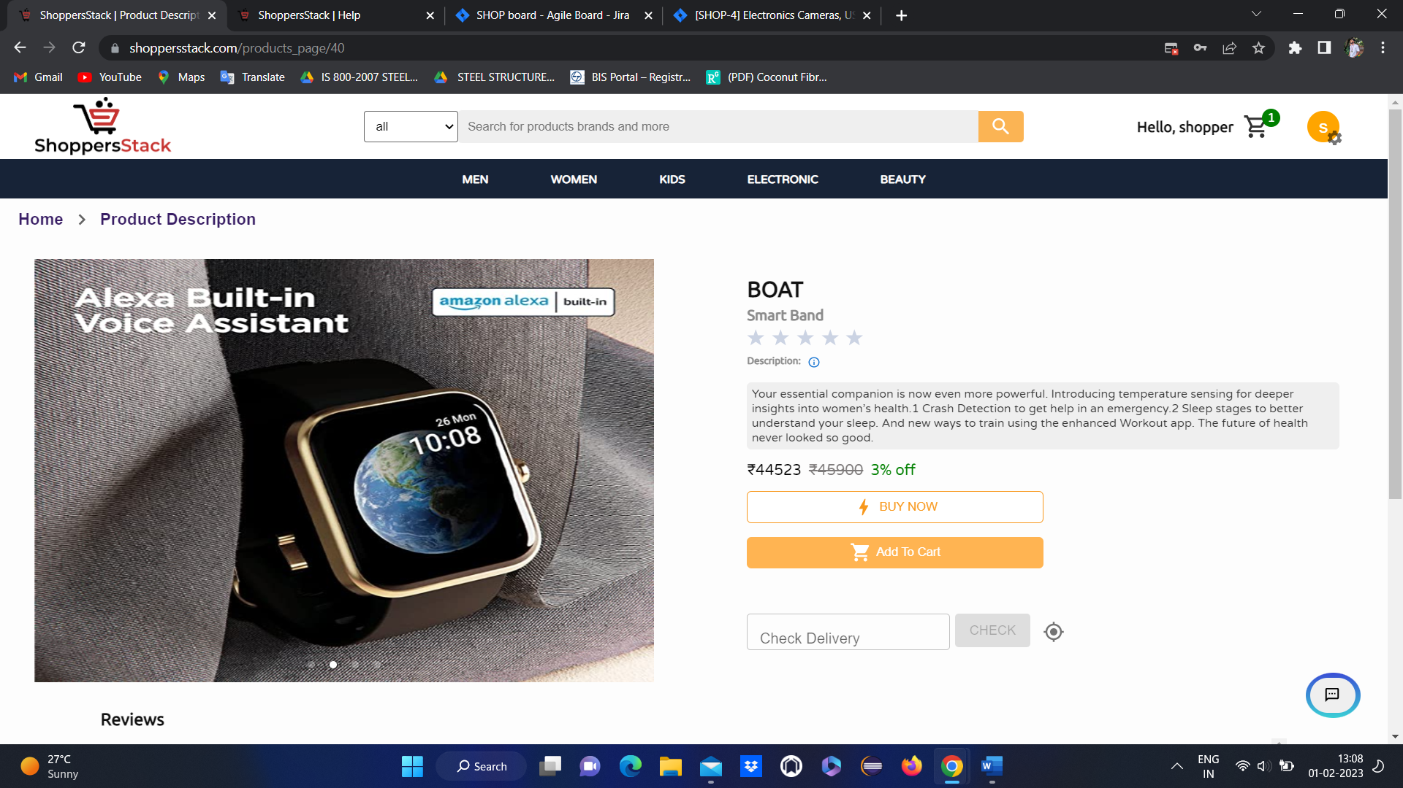

If user wants to perform actions like

Buy now

Add to cart

Add to Wish list etc..

User should be logged in

If user is NOT LOGGED IN and if he is trying to do any actions like

Buy now

Add to cart

Add to Wish list etc.. 🡪 lead to **Shopper login** page



* IF user have an account means have to login by entering registered email and password
* IF user don’t have an account means have to create an account first.

After login

User Home page will be displayed



Again go to respective product page.

1 .When user clicks on COMPARE flipkart page popup is displaying



* Where user can compare the products with flipkart products

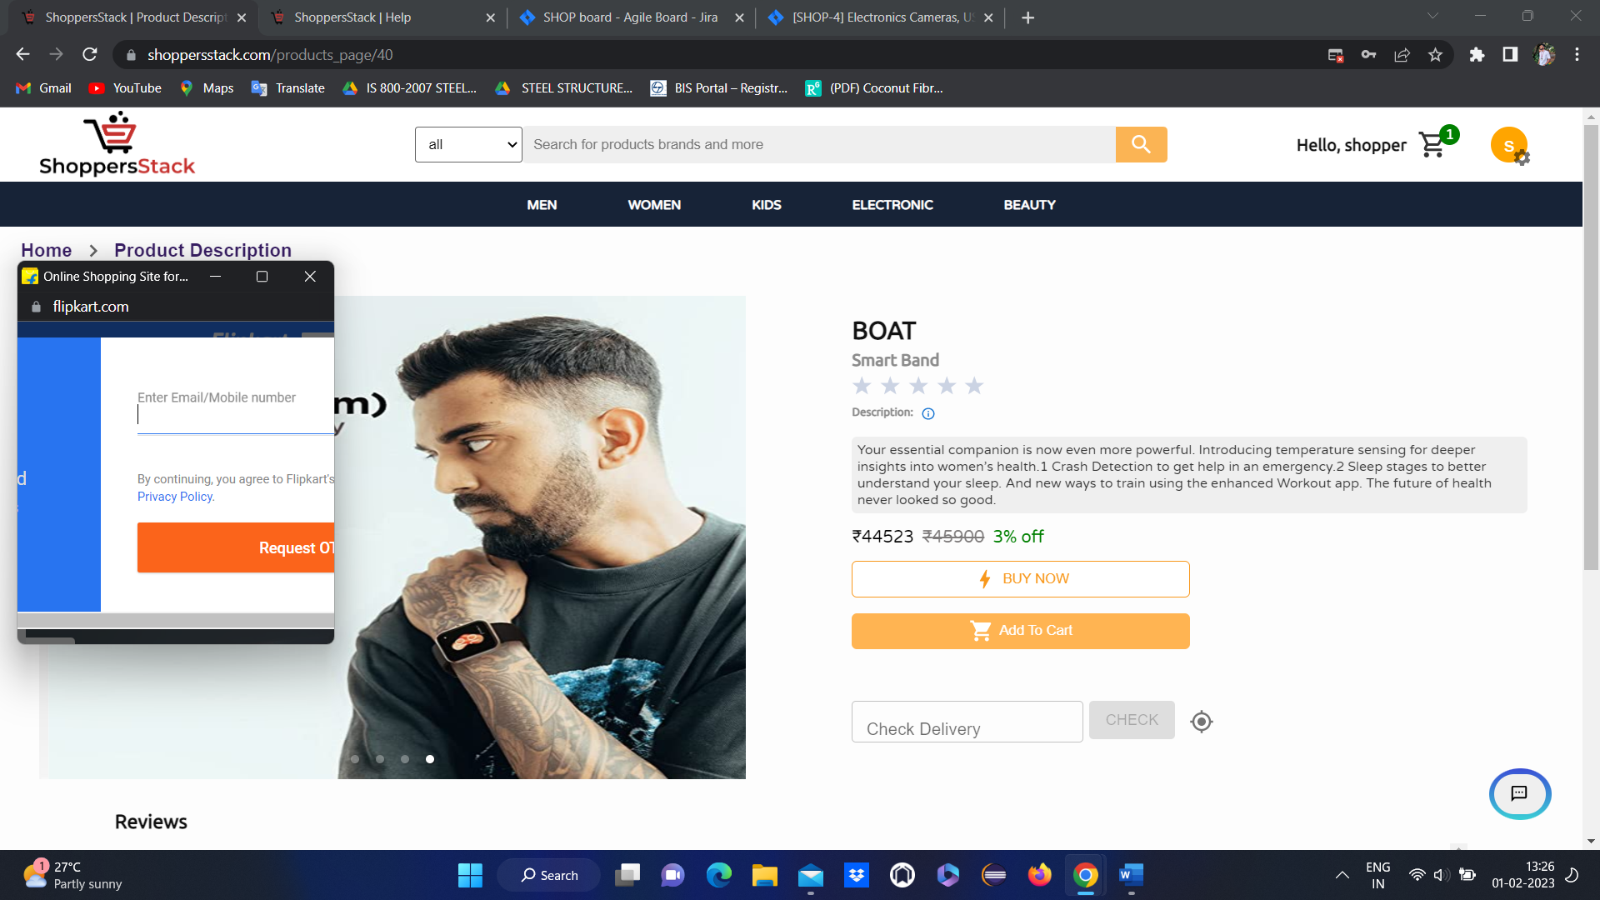

2 .When user wants to add product to cart has to click on add to cart either in product tile or in product description

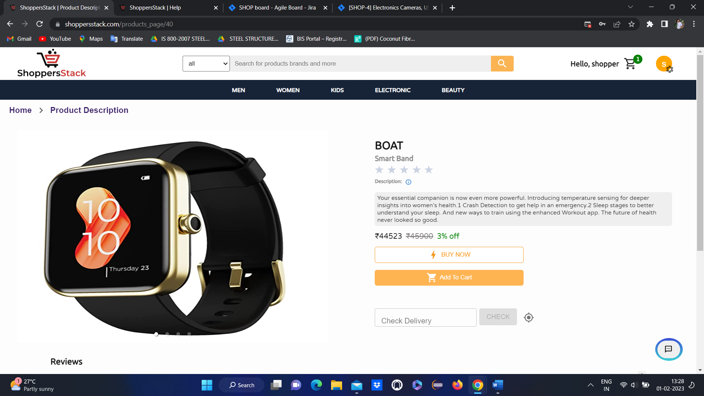

* After clicking on add to cart product will get added to cart.



When the user clicks on the cart symbol

* When the user adds the product to the cart it will display as Added & also in the top left corner we have a cart image where it will be added by displaying the number.
* When the user clicks on the cart symbol added product will be displayed & also it will display details about the product like name, price, offers in percentage, quantity (user can increase and decrease the quantity ) & price details like actual price, discount price, delivery charges & total price.

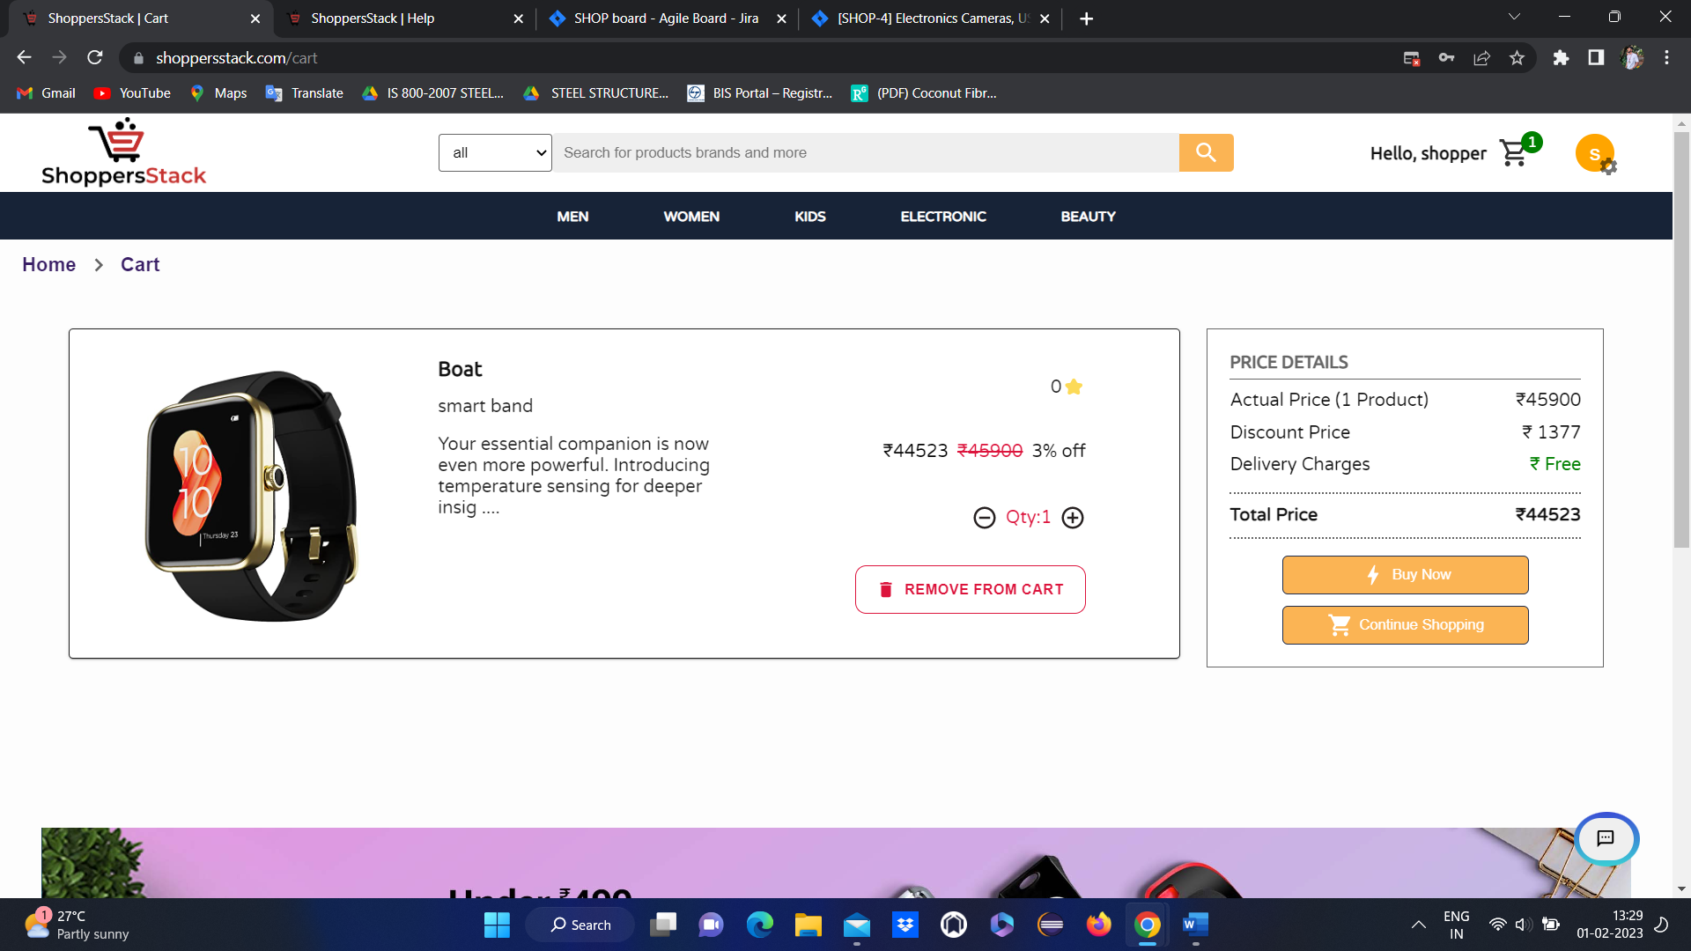

* **If users want to remove the product from the cart by clicking on the remove from cart button, they can remove it**



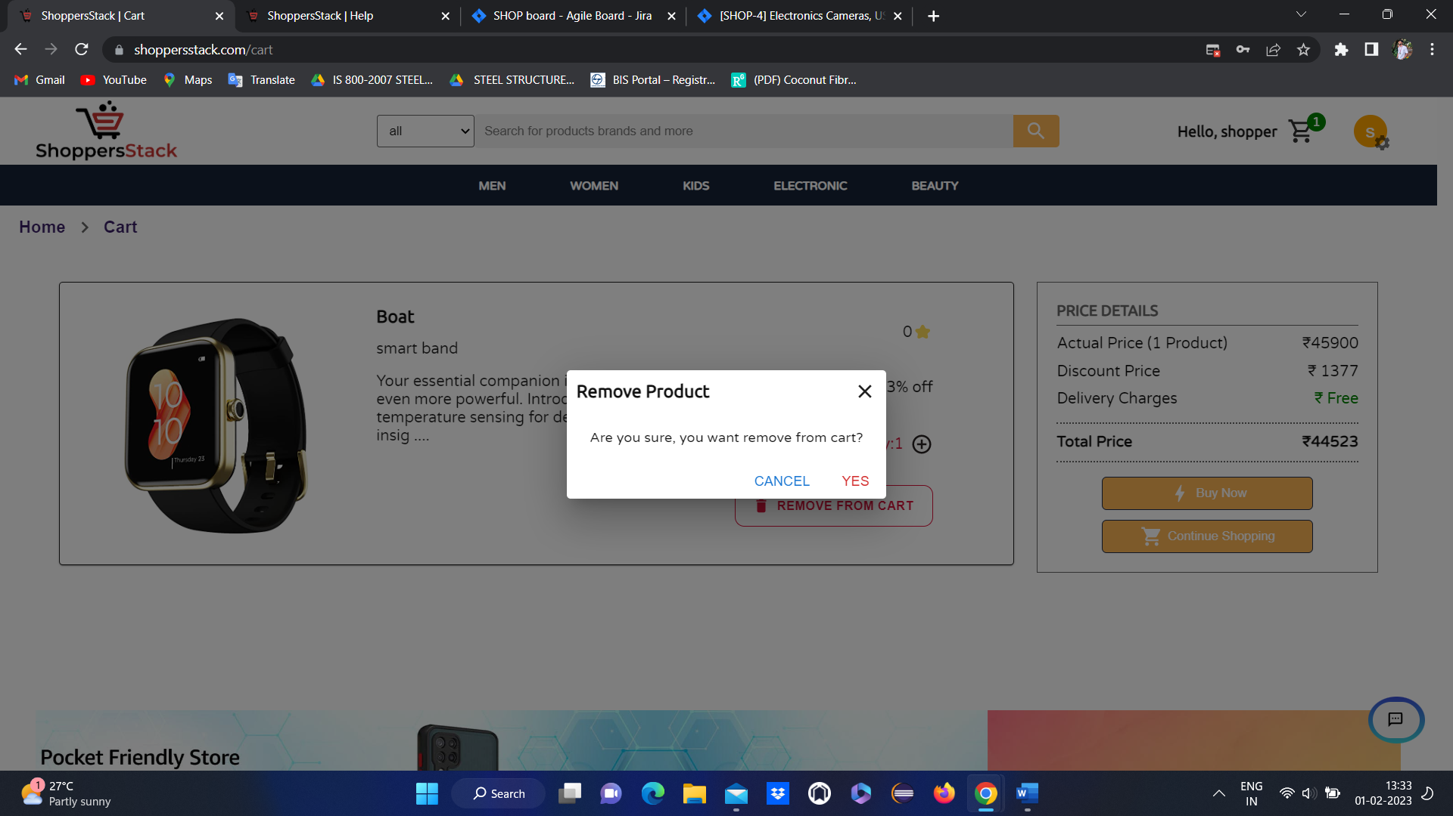

Click on YES

* Product will be deleted and an empty cart will display.



**3 when user wants to buy the product**

Has to click on **buy now** in product description or in cart



* When user clicks on buy now it will goto select delivery address thare user has to add the address
* **NOTE**—if user have an address already means directly it will lead to select delivery address page
* If user wants to add another address means . he can add through **+add new address**



* If user not added any address means user can add the address by clicking on **add new address🡪 add address**



* Here user has to select address type and has to enter name, house info, street info, land mark.
* Select country and state and city
* Enter pincode and phone number

Products are deliverable for some selected pincodes . user can get info about deliverable pins through **deliverable pins** popup.





* When a user entered all the details for the address it will add to the list of addresses & user will a get popup message (successfully added) then the user will once again select the address where they want their product to deliver.



* once again user has to select the address where they want their product to deliver and click on proceed.
* It will go to select payment option method page with the following functionalities like net banking, cash on delivery (COD) & add a card.



* If user selects **net banking** and click on procced . it will go to select bank page
* Here user has to select an option out of the available options like TDFC,

TCICI,TBI, IDHC and click on submit





* After selecting a bank user will go to the net banking login page
* Here user has to enter valid user ID and password and click on submit
* If the user has an invalid User ID & password it will display Invalid bank account credentials, then the user can’t able to complete the payment.
* After login user should click on pay now it will display order confirmation page





* if user selects **cash on** **delivery** and click on proceed order will be confirmed.





* If user wants to pay through card
* User has to add the card by clicking on add card
* It will go to add card page





* User has to enter valid data for all the fields like **cardholder name, card number, PIN, expiry month, expiry year, CVV, Debit or Credit options** and has to click on add
* When users click on electronic & in that if they select COMPUTER HARD DRIVE, the COMPUTER HARD DRIVE section will be displayed and the products will be displayed.

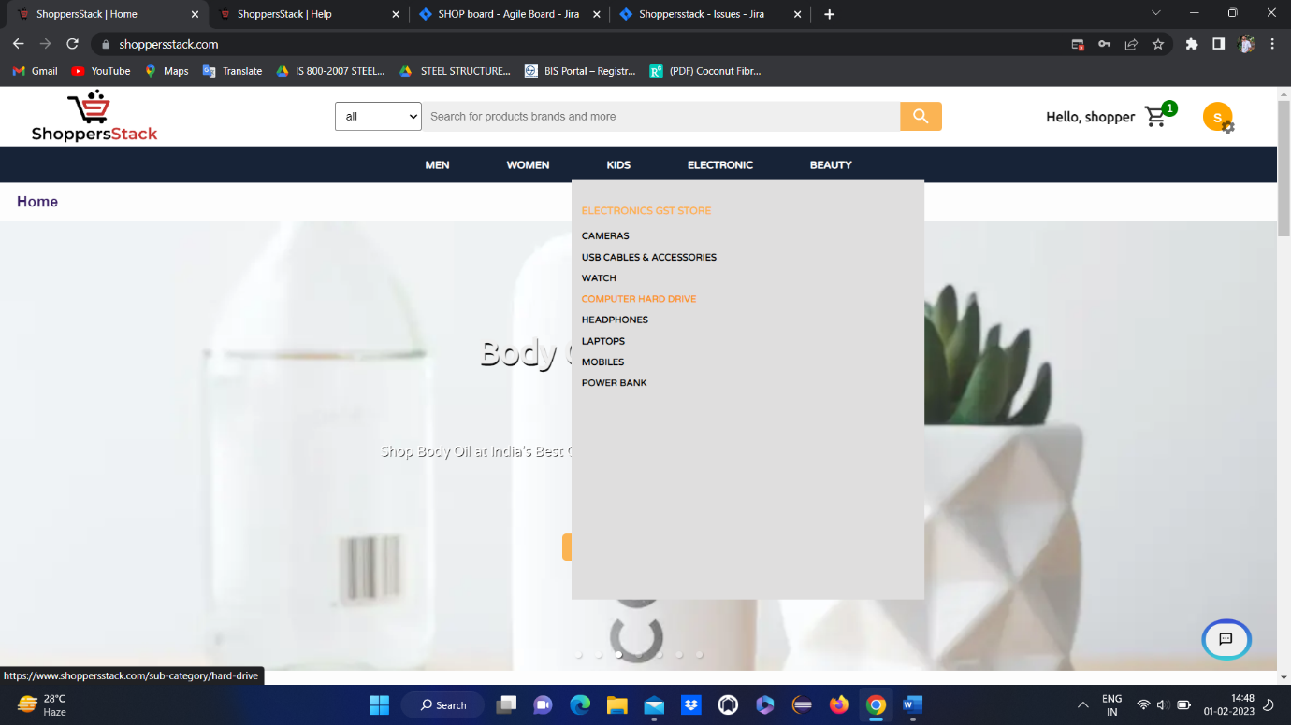

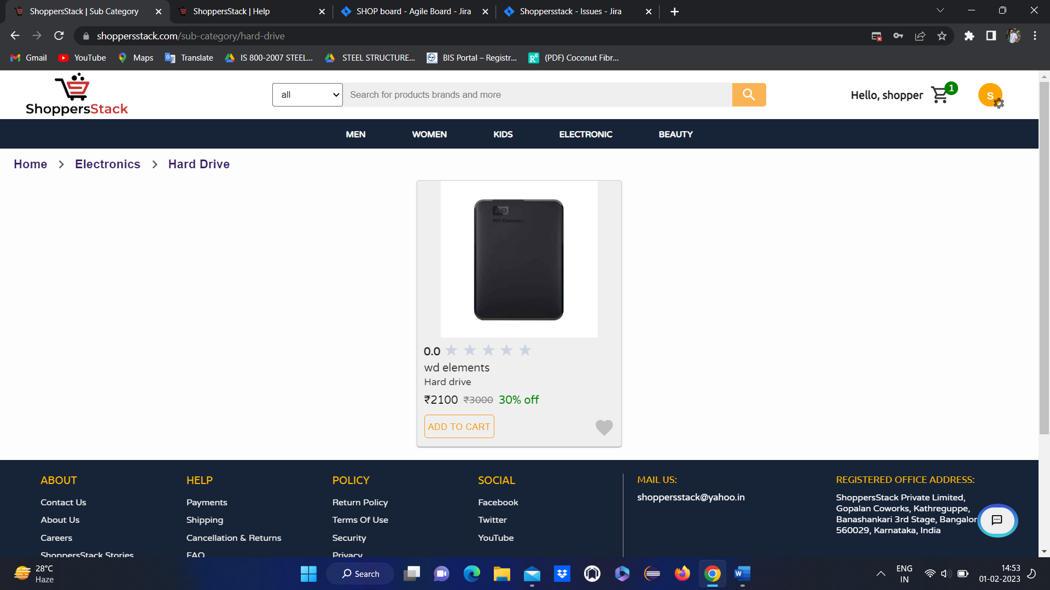

Here user can see

* Product ratings
* Price of the product
* Name of the product
* Discount and original price
* Add to Wishlist

When user clicks on any product🡪product description page will open

With all the information about the product and reviews.

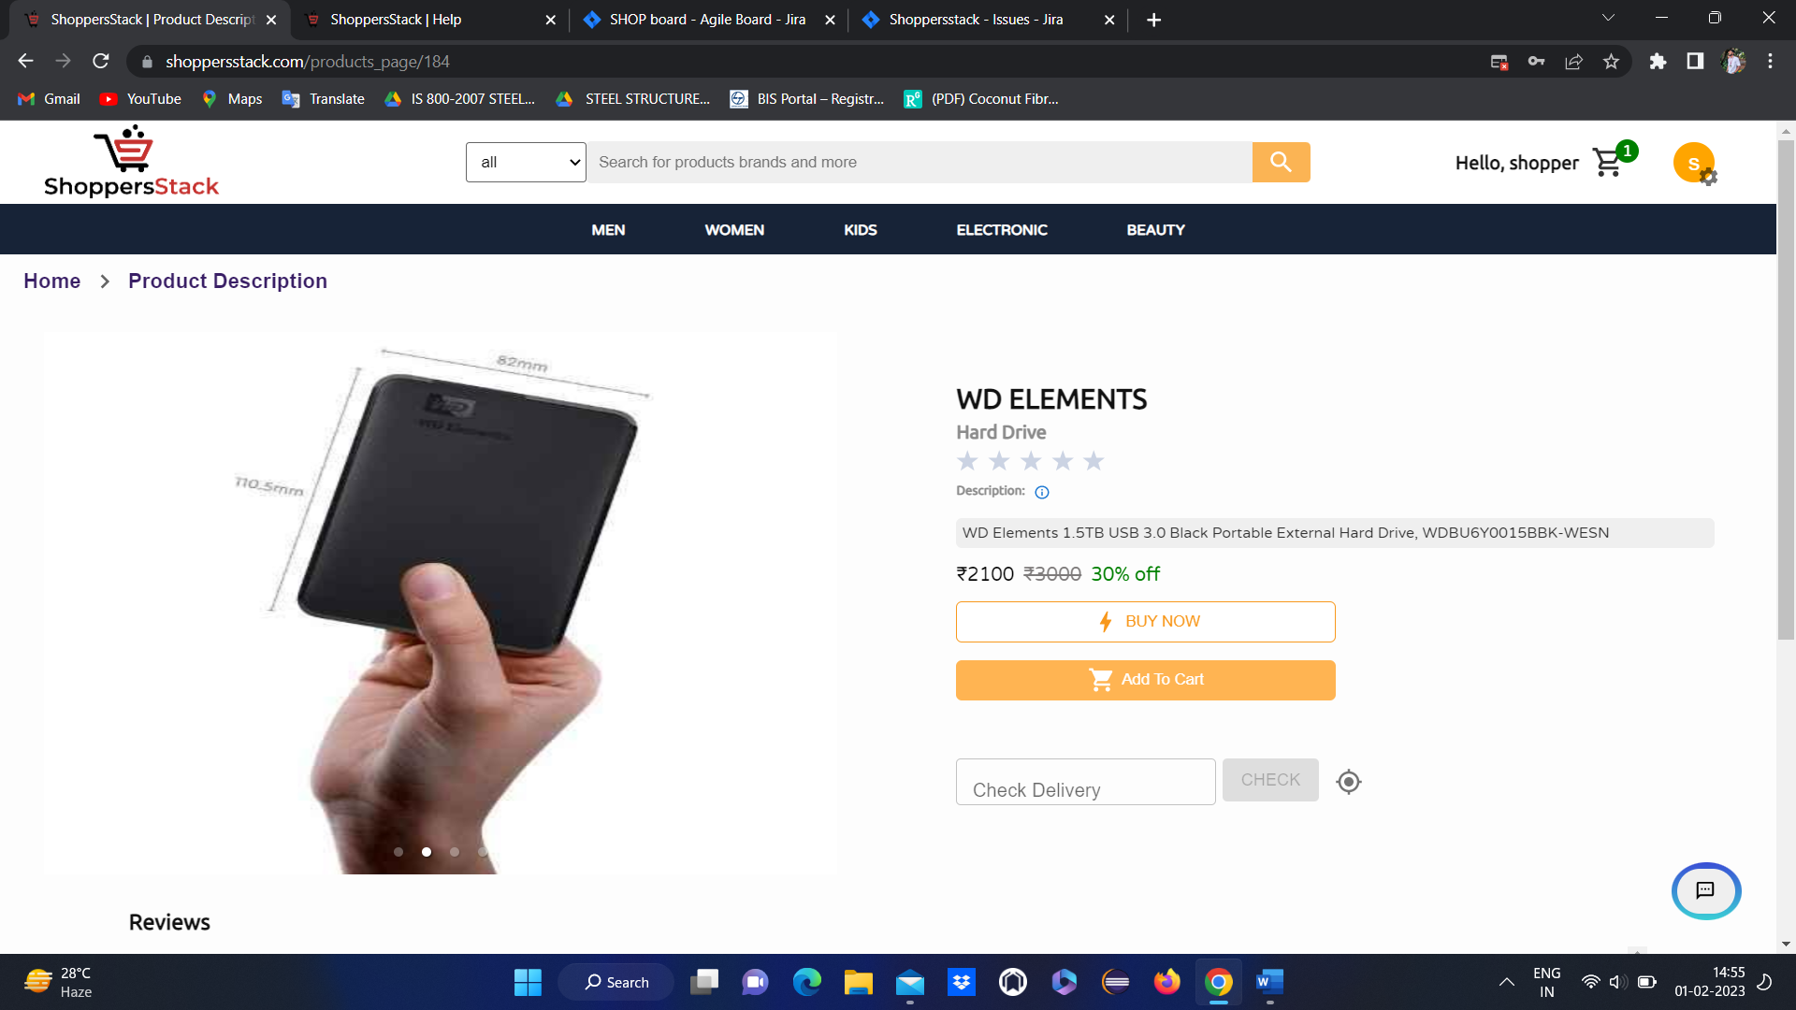

If user wants to perform actions like

Buy now

Add to cart

Add to Wish list etc..

User should be logged in

If user is NOT LOGGED IN and if he is trying to do any actions like

Buy now

Add to cart

Add to Wish list etc.. 🡪 lead to **Shopper login** page



* IF user have an account means have to login by entering registered email and password
* IF user don’t have an account means have to create an account first.

After login

User Home page will be displayed



Again go to respective product page.

1 .When user clicks on COMPARE flipkart page popup is displaying



* Where user can compare the products with flipkart products

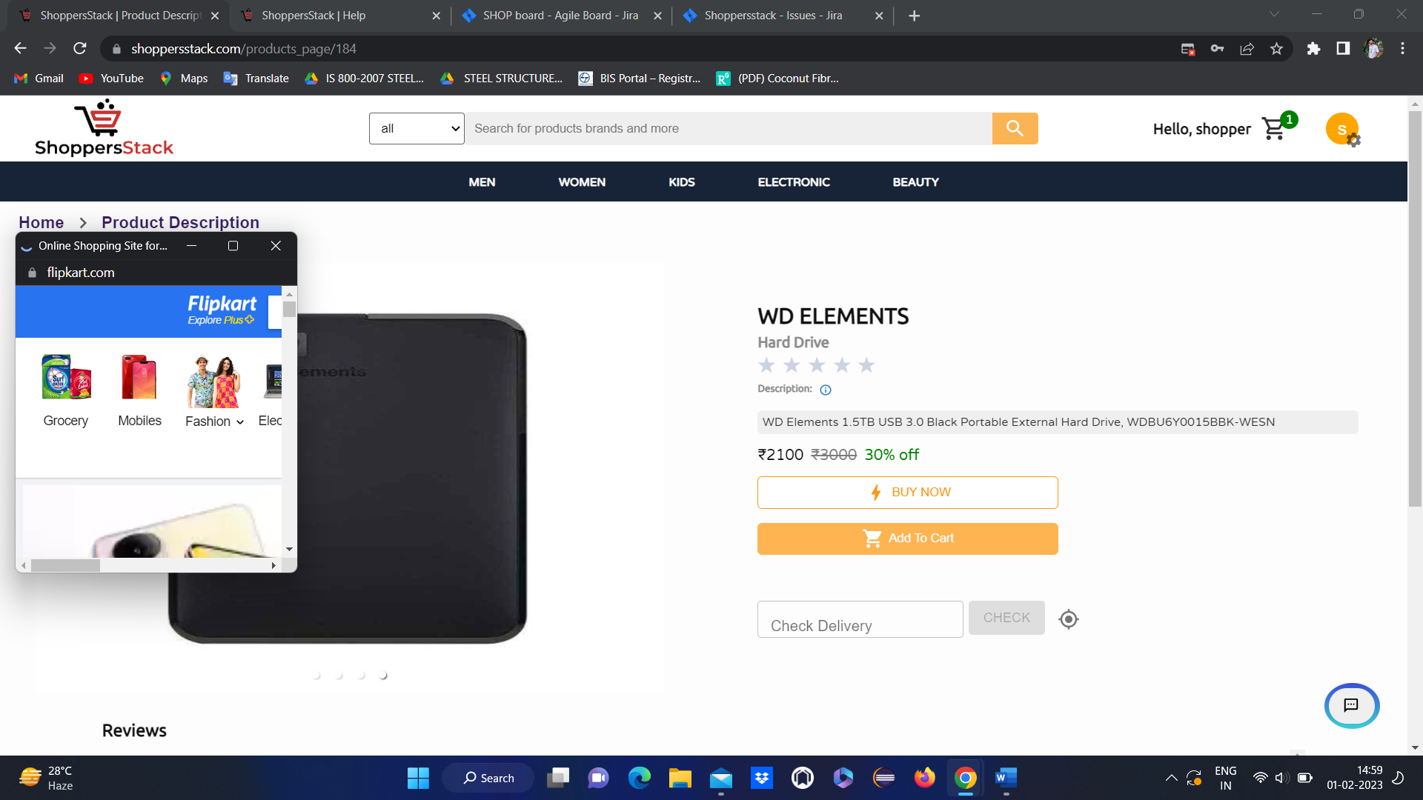

2 .When user wants to add product to cart has to click on add to cart either in product tile or in product description



* After clicking on add to cart product will get added to cart.

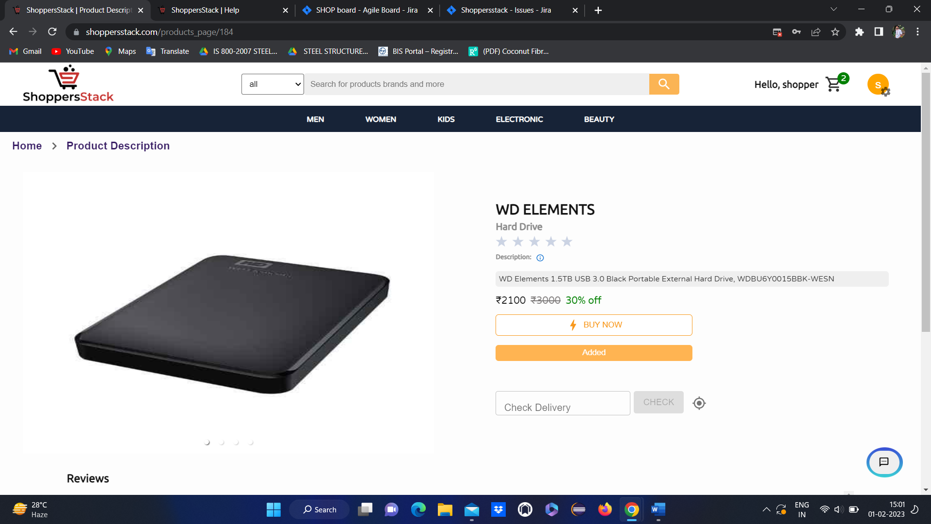

When the user clicks on the cart symbol

* When the user adds the product to the cart it will display as Added & also in the top left corner we have a cart image where it will be added by displaying the number.
* When the user clicks on the cart symbol added product will be displayed & also it will display details about the product like name, price, offers in percentage, quantity (user can increase and decrease the quantity ) & price details like actual price, discount price, delivery charges & total price.

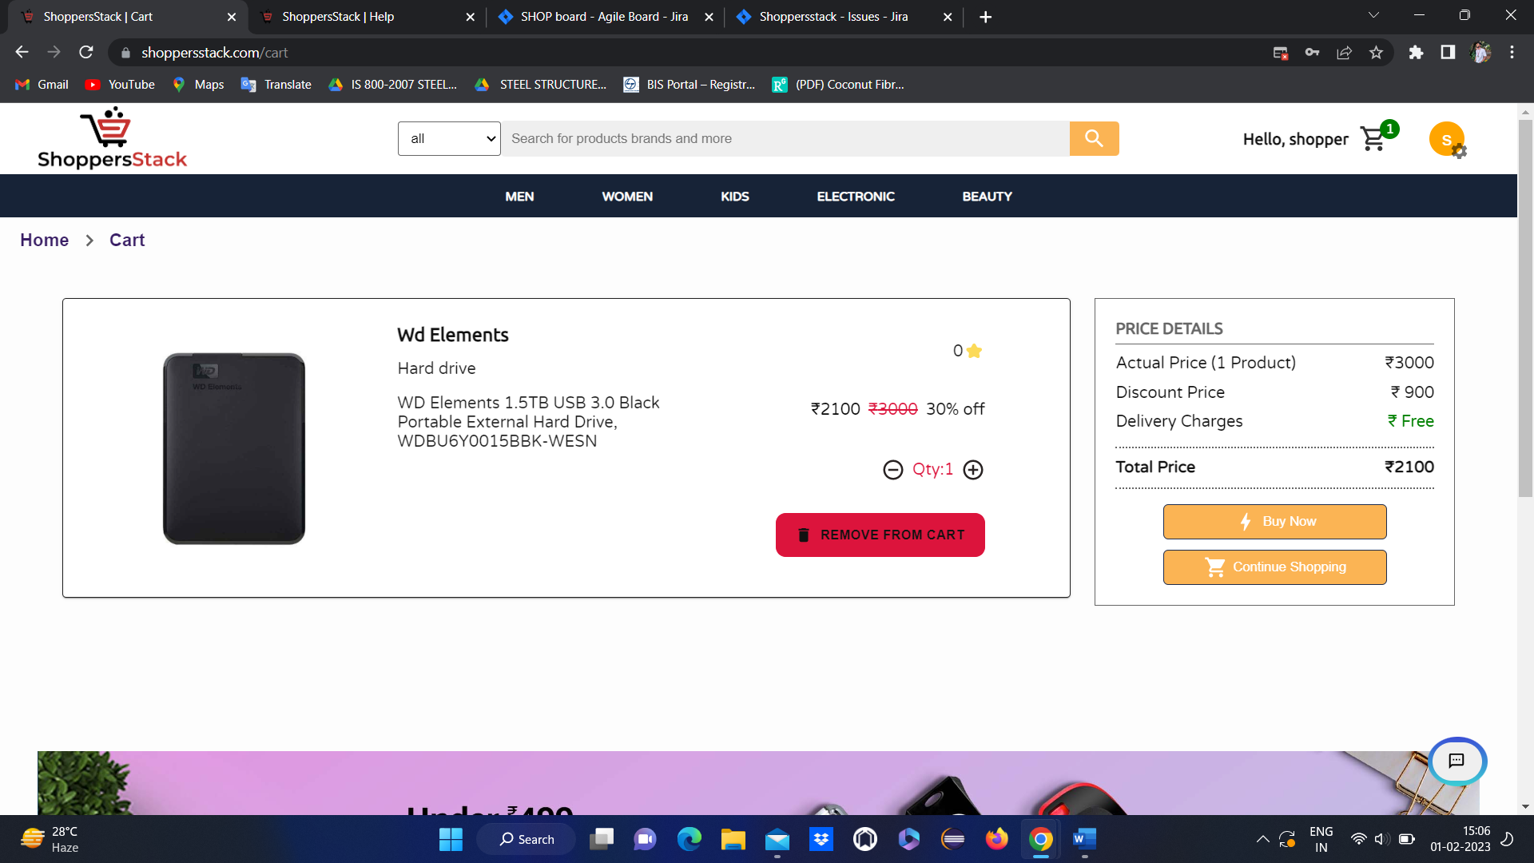

* **If users want to remove the product from the cart by clicking on the remove from cart button, they can remove it**



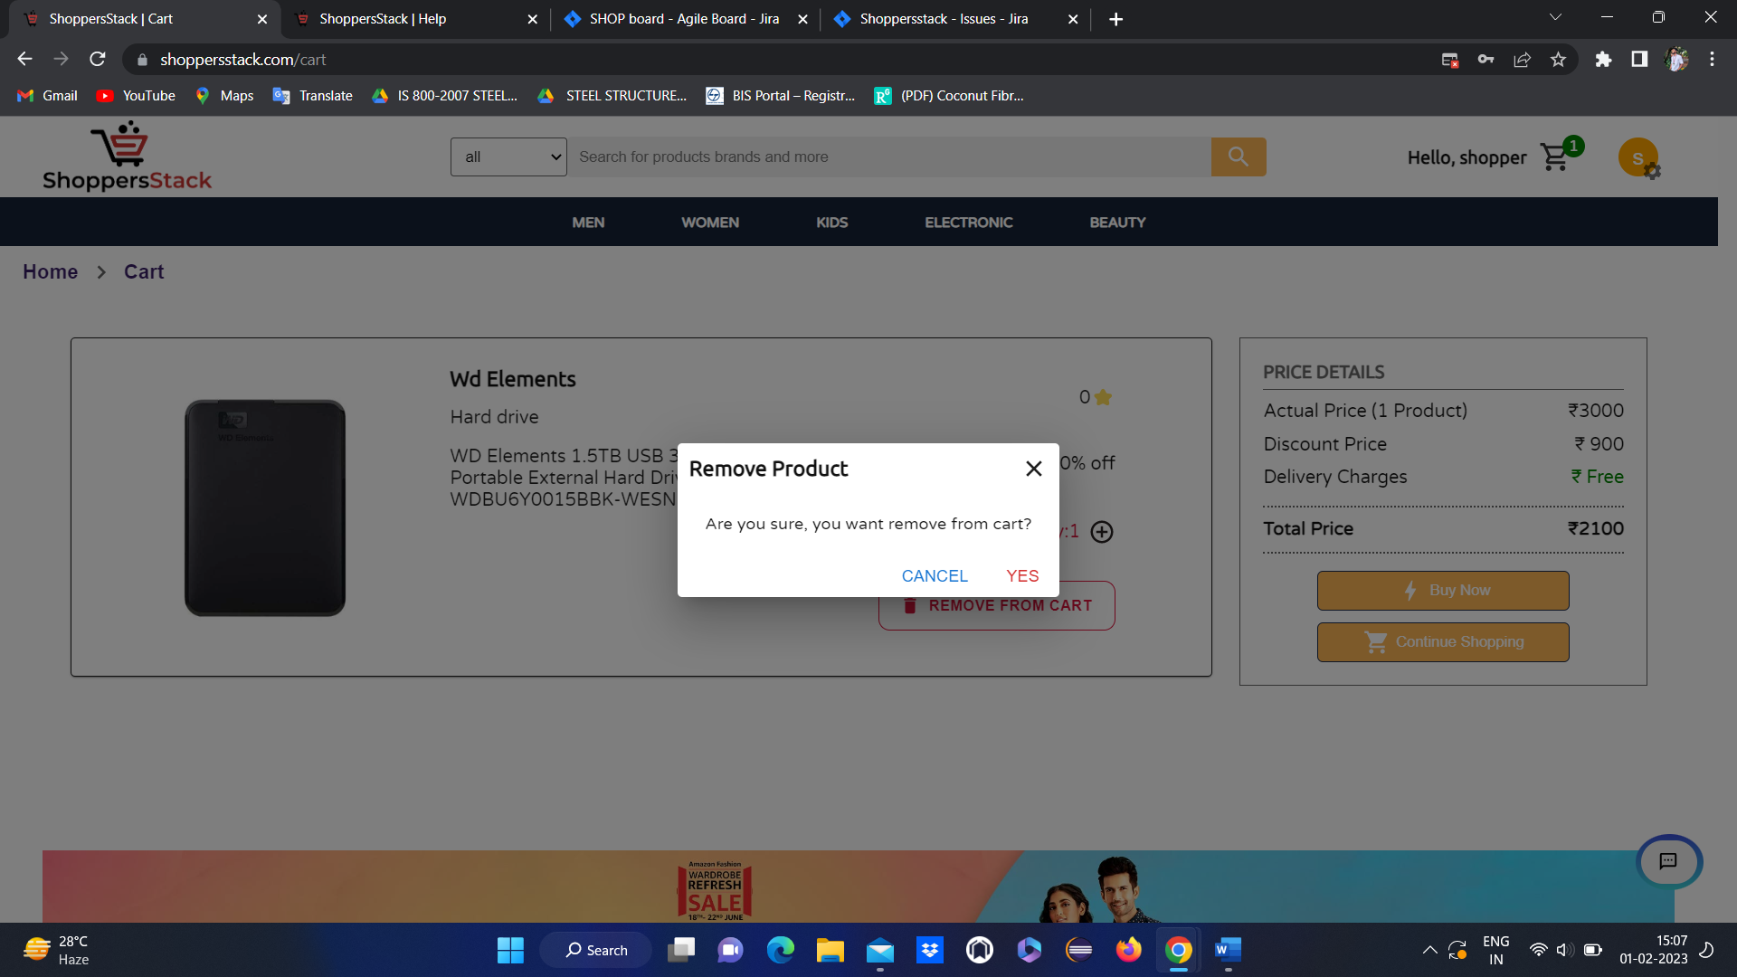

Click on YES

* Product will be deleted and an empty cart will display.



**3 when user wants to buy the product**

Has to click on **buy now** in product description or in cart



* When user clicks on buy now it will goto select delivery address thare user has to add the address
* **NOTE**—if user have an address already means directly it will lead to select delivery address page
* If user wants to add another address means . he can add through **+add new address**



* If user not added any address means user can add the address by clicking on **add new address🡪 add address**



* Here user has to select address type and has to enter name, house info, street info, land mark.
* Select country and state and city
* Enter pincode and phone number

Products are deliverable for some selected pincodes . user can get info about deliverable pins through **deliverable pins** popup.





* When a user entered all the details for the address it will add to the list of addresses & user will a get popup message (successfully added) then the user will once again select the address where they want their product to deliver.



* once again user has to select the address where they want their product to deliver and click on proceed.
* It will go to select payment option method page with the following functionalities like net banking, cash on delivery (COD) & add a card.



* If user selects **net banking** and click on procced . it will go to select bank page
* Here user has to select an option out of the available options like TDFC,

TCICI,TBI, IDHC and click on submit





* After selecting a bank user will go to the net banking login page
* Here user has to enter valid user ID and password and click on submit
* If the user has an invalid User ID & password it will display Invalid bank account credentials, then the user can’t able to complete the payment.
* After login user should click on pay now it will display order confirmation page





* if user selects **cash on** **delivery** and click on proceed order will be confirmed.





* If user wants to pay through card
* User has to add the card by clicking on add card
* It will go to add card page





* User has to enter valid data for all the fields like **cardholder name, card number, PIN, expiry month, expiry year, CVV, Debit or Credit options** and has to click on add